**Chapter: 1**

**Introduction**

* 1. **Objective:**

The objective of ‘Project Management Tool’ is to distribute different project modules to different project developer and teams and developer team develop the project according to module and duration after that each member of development team upload their work status daily to daily that can view by admin. It provides work report, project status report, duration, time estimation of project. In this client can see their project status and any query then can able to ask to experts of development team.

**1.2 Motivation:**

Project Management Tool will be very helpful. Here we are trying to develop an application that provides a secure way to perform all activities related to project development within company.

In this project client direct interact to the company experts after accessing it. And admin and all employees can immediate starts their work very easily and frequently.

The development of this new system contains the following activities, which try to automate the entire process keeping in the view of database integration approach.

* This system maintains client’s personal address, contact and project details.
* User friendliness is provided in the application with various controls provided by system rich user interface.
* The system gives us high security for saving data because user authentication is high and there are no chances of data losing.
* This system makes the overall project management much easier and flexible.
* Various classes have been used for maintain the details of all the clients, developer and managers and work log.
* Authentication is provided for this application only registered users can access.
* Report generation features is provided using to generate different kind of reports.
* The system provides facilities to track the all activities of project development by the admin and project manager.
* System can also help to track all the employees work report and [project status daily to daily.
* System provides facility to approve and block the project, clients, project manager and developer.
* System also provides facility to upload project work status daily to daily by developers.
* The system provides facility to do all activities related to project management within a company.
* By this system all activities perform online like- project assignment, query of client, reporting of project so it will be easier to development team that can be able develop project by living anywhere in the world.
* The system provides facility to store project records that can’t be leak.

This system is providing feature to see project status by the client any time by login.

* 1. **Problem Domain:**

Generally in Existing System all works are perform manually or by e-mail like-work report, project status report, duration, time estimation of project which are developing in a company, so some problems are occurred as follows:

* The existing system not provide feature to assign project module to developer in secure way, so here is less security.
* This existing system is not providing secure registration and profile management of all the users properly.
* The system doesn’t provide facility to track all the activities of project manager and under working project developer. So can’t track any activity of project development of a company easily.
* This manual system gives us very less security for saving data and some data may be lost due to mismanagement.
* The system doesn’t provide any facility to maintain any query to expert by client. So any client asks their own queries to expert. So there is no interaction of client with company.
* The system doesn’t provide any functionality to upload project status by manager, so client can’t view their project status, it is more complex that if any client want to see their project status.
* This system doesn’t provide approve and block developer, project, project manager and client through online. These all work done by manually.
* In existing system in companies’ project assignment done by mail or manually that is less secure compare to proposed system.
* The system doesn’t provide any functionality to Secrete Admin and client chatting online chatting.

So we need to solve all problems as mentioned above by developing a project that is Project management tool that will be very helpful to perform all activities related to project development within a company very easily.

**Project Management Tools contains following modules:**

1. **Administrator:** This module provides all facilities to admin to handle project, developer, project manager and client report.

Admin can also view the whole project report. This module provides following features: Approve Block Developer means admin can approve developer to work on project and can also block the developer if work completed, Approve Block Project means admin can approve any project to start development and can block the project after completion, Approve Block Project Manager means admin can approve project manager to manage project and block the manager to manage project, Approve Block client means approve client to post their project and query if needed, View Project Report means admin can see project report that is developed.

1. **Project Manager:** This module provides facilities to project manager to handle project. Project Manager can handle following activities: add project, edit project, delete project and project assignment to project developers. Project Manager can perform all activities after login. Initially Project manager need to register.
2. **Developers:** This module will be able manage all activities of developer related to project development. Developer can register and login by this after that can submit daily work report and also can see self work log in their profile, after doing required activities developer can logout.
3. **Clients:** By the help of this module client can do registration for posting their project and after login can asks from expert if has any query. There is view project status option by which client can see their project status if wants after that can logout by the help of logout option.

Now-a-days, almost all organizations are doing their works online by the application, like Storing records of daily activities and any advertisement related to project development. It saves clients, developer, manager and admin time to perform activities of project development. Because All Activities related to development perform direct in hardcopy or by mail is very complex as well as time consuming.

We are conceptualizing this software as a solution so that any software company employees and client can communicate through this Software for the software development in a secure way. And maintain the security of the project development within company.

The manager can block the developer if required and if developer blocked by admin or project manager then developer can’t do their work like this admin can block manager, developer and client. Firstly client will register on this after that if admin approve the client after that client can able to post their project.

Organization can also easily check the performance of the manager and developers. It will be very easy to track all the activities within organization and admin and manager able to so the performance of developer. It also helps the company to make project development very easily.

According to today’s requirement, any developer live in out of company location and not able to come in organization if any company wants to hire for project development then this software can be helpful. By the help of this software manager can assign the project module to developer in very secure way very easily.

The system also provides facilities to client that can view their project status and if client wants modification or query from expert then he can ask from this software. System also tracks the tips and suggestion online.

System provides facility to approve and block the project, employee and clients. System also provides facility to upload daily to daily work report by developer and manager. By the help of this software it is possible that no need to come into company to do work.

This system is providing more memory for the company to maintain data related to project development.

**1.4 Technology Used**

**Front End Tools**

After making the java program the structure which comes after running in front of user called Front End. Lookup of webpage’s and applications come under the Front End. . Several technological tools will use for front end in this project; each is summarized in the sections that follow:

# Html

Html stands for hyper text markup language. A markup language is a language that annotates text in a way that is syntactically distinguishable so that the computer can manipulate it. It is a set of markup tags used to describe web pages. The tags are what separate normal text from html code. They are the words between the <angle-brackets>. Markup is what html tags do to the text inside them. They mark it as a certain type of text. Html documents contain html tags and plain text.

**CSS**

CSS stands for cascading style sheets. It is used to control the style and layout of multiple web pages all at once. Styles define how to display html elements. They are stored in css files. Style sheets contain rules, composed of selectors and declarations that define how styles will be applied.

**JavaScript**

JavaScript is the scripting language of the web. All modern html pages are using javascript. A scripting language is a lightweight programming language. JavaScript code can be inserted into any html page, and it can be executed by all types of web browsers. JavaScript is easy to learn.

# Bootstrap

# Bootstrap is a free and open-source front-end framework for designing websites and web applications. It contains html- and css-based design templates for typography, forms, buttons, navigation and other interface components, as well as optional JavaScript extensions. Unlike many earlier web frameworks, it concerns itself with front-end development only.

**Features of bootstrap**

* **Easy to begin with**

It is pretty easy, to begin with. Being easy to get started with is probably the first quality which makes bootstrap very appealing.

* **Less as well as css files**

Bootstrap not only offers less files but also includes the old css files.

* **Responsive utility classes**

Another prominent feature of bootstrap is its responsive utility classes. Using responsive utility classes, a particular piece of content can be made to appear or hide only on devices depending on the size of the screen being used.

**Components of bootstrap**

Some of the components that come pre-styled in bootstrap are

* Drop-downs
* Button
* Navigation
* Badges alerts
* Progress bar

**Core Java:** Core java is used to create the structure of the web document. It defined the outlook of the page. Everything that is watch able in the screen in front of user is made by java. Here provides great features to making our applications pages good in watch.

**Advance Java:** advance java is available to use some extended features. Here available some heavy features for creating the pages of very better quality. The task done by advance java will be very good as compared to the core java. Many extended features are available here to perform some very special tasks.

**Back End Tools**

When a page of web or of application or etc comes in front of user and that wants inputs from user side to perform the particular task according to user. The inputted information by the user will be going to the Database through the Hibernate using MySQL database.

* **Hibernate:** Hibernate is the ORM tool given to transfer the data between a java (object) application and a database (Relational) in the form of the objects.  Hibernate is the open source light weight tool given by **Gavin King**. Hibernate is a non-invasive framework,  means it won’t forces the programmers to extend or implement any class or interface, and in hibernate we have all POJO classes so its light weight. Hibernate can run with in or without server, means it will suitable for all types of java applications

Hibernate is purely for persistence (to store or retrieve data from Database).

* **Spring:** Spring is a light weight and open source framework created by Rod Johnson in 2003. Spring is a complete and a modular framework, means spring framework can be used for all layer implementations for a real time application or spring can be used for the development of particular layer of a real time application unlike struts (only for front end related) and hibernate (only for database related), but with spring we can develop all layers. Spring framework is said to be a non-invasive means it doesn’t force a programmer to extend or implement their class from any predefined class or interface given by Spring API, in struts we used to extend Action Class right that’s why struts is said to be invasive.

By the help of spring we can develop web application, In this an application developed in three layers Model, View and Controller layer such that a project that is developed using spring is more understandable for the developer and coding is saperate in three layers that makes understandability. All the pages that can vie by the users are contains inside the view layer, all pages related to project logic are contains in model layer and controller layer is responsible to handle all page requests.

**MySQL Database:** MySQL is [free and open-source software](https://en.wikipedia.org/wiki/Free_and_open-source_software) under the terms of the [GNU General Public License](https://en.wikipedia.org/wiki/GNU_General_Public_License), and is also available under a variety of [proprietary](https://en.wikipedia.org/wiki/Proprietary_software) licenses. MySQL was owned and sponsored by the [Swedish](https://en.wikipedia.org/wiki/Sweden) company [MySQL AB](https://en.wikipedia.org/wiki/MySQL_AB), which was bought by Sun Microsystems (now [Oracle Corporation](https://en.wikipedia.org/wiki/Oracle_Corporation)). In 2010, when Oracle acquired Sun, Widenius forked the [open-source](https://en.wikipedia.org/wiki/Open-source) MySQL project to create [MariaDB](https://en.wikipedia.org/wiki/MariaDB).

**Chapter: 2**

**Hardware/Software Requirements**

* 1. **Hardware Requirement**

**Hardware:** The external things which are really important things to be help in our software to execute it by using all the features of the software. Like: Mouse, Keyboard, Monitor CPU, hard disk and chips.

**Mouse:** A mouse is a handheld pointing device used to position a cursor on a computer screen. This allows the user to select items stored on a computer and, subsequently, perform actions on those items.

**Keyboard:** A computer keyboard is an input device used to enter characters and functions into the computer system by pressing buttons, or keys

**Monitor:** A computer monitor is a display adapter that displays information processed by the computer

**CPU:** The central processing unit (CPU) of a computer is a piece of hardware that carries out the instructions of a computer program.

**Memory:** Computer memory is the storage space in the computer, where data is to be processed and instructions required for processing are stored. Memory is the storage space in the computer, where data is to be processed in sequence order and instructions required to process are stored. The area of the computer system where all the process running and result of that all process stored to the area is known as Memory. One of very important he part of our computer system, which takes place in every process to complete that particular process and result too.

* 1. **Software Requirement**

1. **Software:** Software’s are those which provides the required writing area for the programming ad applying our all the logics. That can help us various types like provide writing area for developing our logics and provide debug system and provides compile and running environment to find the optimize results of the logic and development.

Operating System Windows XP/07 or Linux

User Interface HTML, CSS

Client-side Scripting JavaScript

Programming Language Java

Web Applications Spring MVC

IDE/Workbench eclipse-jee-neon-3

Database MySQL

Server Deployment Tomcat 6.x/7.x

**Eclipse IDE (eclipse-jee-neon-3):**

Eclipse is an [integrated development environment](https://en.wikipedia.org/wiki/Integrated_development_environment) (IDE) used in [computer programming](https://en.wikipedia.org/wiki/Computer_programming), and is the most widely used Java IDE. It contains a base [workspace](https://en.wikipedia.org/wiki/Workspace) and an extensible [plug-in](https://en.wikipedia.org/wiki/Plug-in_(computing)) system for customizing the environment. Eclipse is written mostly in [Java](https://en.wikipedia.org/wiki/Java_(programming_language)) and its primary use is for developing Java applications, but it may also be used to develop applications in other [programming languages](https://en.wikipedia.org/wiki/Programming_language).

Eclipse is released under the terms of the Eclipse Public License. Eclipse platform can be used to develop rich client applications, integrated development environments and other tools. Eclipse can be used as an IDE for any programming language for which a plug-in is available. Eclipse got its start in 2001 when IBM donated three million lines of code from its Java tools to develop an [open source](https://whatis.techtarget.com/definition/open-source) integrated development environment ([IDE](https://searchstorage.techtarget.com/definition/IDE)).

Eclipseis software that is commercially used in the software industry for development related work that all developments can be done through the java specially. All types of the real world applications can be developed by this IDE. Eclipse provide very easy interface to apply our coding. If we write something in the writing session of the eclipse then we will find that number of many more words will be come out over there in the same position. We can select one of them as for our requirements.

So by these features, I have chooses the eclipse to be work with for developing my project/software. It. makes power full workspace for saving the project whatever done by the developers according their requirement for their real time projects to be done.

It provides the....

**Editor:** The area where we write our code for implementation of our web applications, console application and many more development related works.

And for running this project or software the user’s will have to use any of the browser available in the market, and for running it in the browser we prefer for the Google chrome only apart from it user’s can also use internet explorer and etc. Google chrome is very easy to handle my software where many number of the user can register himself and take the profit from there for shopping and etc. Also for some the medical stores which are in the situation where some time they cannot run their business successfully.

So it is very good platform to run their own business in my software they can have online orders of the products of user from his same city where he belong from. The main work to run my software in browser is the task of the server, which handles number of processes in single second.

**Hibernate Framework (hibernate 3.0):**

Hibernate is the open source, non-invasive, light-weight java ORM tool given to transfer the data between a java (object) application and a database (Relational) in the form of the objects.  Hibernate is the open source light weight tool given by **Gavin King**.

Hibernate can runs with in or with out server, means it will suitable for all types of java applications.

**Framework** means it is special install-able software that provides abstraction layer on one or more technologies like JDBC, Servlet etc to simplify or reduce the complexity for development process.

**Open Source means:**

* Hibernate framework is available for everyone without any cost.
* The source code of Hibernate is also available on the Internet and we can also modify the code.

**Light-weight means:**

* Hibernate is less in size means the installation package is not big is size.
* Hibernate does not require any heavy container for execution.
* It does not require POJO and POJI model programming.
* Hibernate can be used alone or we can use Hibernate with other java technology and framework.

**Non-invasive means:**

* The classes of Hibernate application development are loosely coupled classes with respect to Hibernate API i.e. Hibernate class need not to implement hibernate API interfaces and need not to extend from Hibernate API classes.

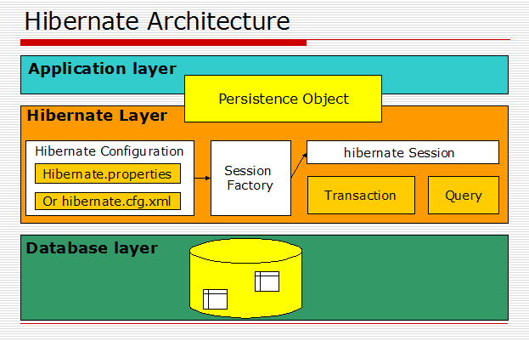

**Spring Framework (Spring MVC):** A Spring MVC is a Java framework which is used to build web applications. It follows the Model-View-Controller design pattern. It implements all the basic features of a core spring framework like Inversion of Control, Dependency Injection.

A Spring MVC provides an elegant solution to use MVC in spring framework by the help of **DispatcherServlet**. Here, **DispatcherServlet** is a class that receives the incoming request and maps it to the right resource such as controllers, models, and views.

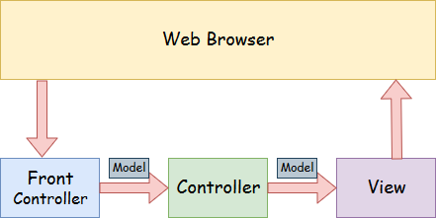

* **Model** - A model contains the data of the application. A data can be a single object or a collection of objects.
* **Controller** - A controller contains the business logic of an application. Here, the @Controller annotation is used to mark the class as the controller.
* **View** - A view represents the provided information in a particular format. Generally, JSP+JSTL is used to create a view page.
* **Front Controller** - In Spring Web MVC, the DispatcherServlet class works as the front controller. It is responsible to manage the flow of the Spring MVC application.

Advantages of Spring MVC Framework:-

* **Separate roles** - The Spring MVC separates each role, where the model object, controller, command object, view resolver, DispatcherServlet, validator, etc. can be fulfilled by a specialized object.
* **Light-weight** - It uses light-weight Servlet container to develop and deploy your application.
* **Powerful Configuration** - It provides a robust configuration for both framework and application classes that include easy referencing across contexts, such as from web controllers to business objects and validator.
* **Rapid development** - The Spring MVC facilitates fast and parallel development.
* **Reusable business code** - Instead of creating new objects, it allows us to use the existing business objects.
* **Easy to test** - In Spring, generally we create JavaBeans classes that enable you to inject test data using the setter methods.
* **Flexible Mapping** - It provides the specific annotations that easily redirect the page.

**OS (windows):** manage the computer's resources, such as the central processing unit, memory, disk drives, and printers, establish a user interface, and execute and provide services for applications software.

**JDK:** JDK is an acronym for Java Development Kit. It physically exists. It contains JRE + development tools.

**JVM:** JVM (Java Virtual Machine) is an abstract machine. It is a specification that provides runtime environment in which java byte code can be executed.

JVMs are available for many hardware and software platforms. JVM, JRE and JDK are platform dependent because configuration of each OS differs. But, Java is platform independent. There are three notions of the JVM: specification, implementation, and instance.

The JVM performs following main tasks:

* Loads code
* Verifies code
* Executes code
* Provides runtime environment

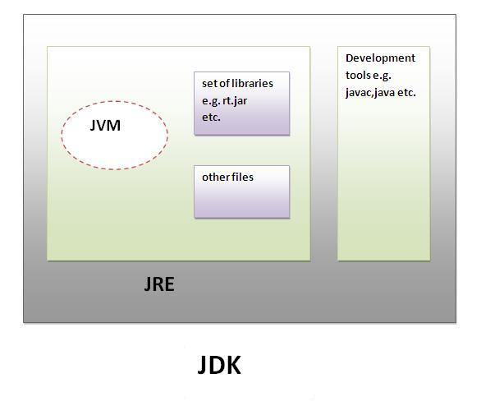

### JRE: JRE is an acronym for Java Runtime Environment. It is used to provide runtime environment. It is the implementation of JVM. It physically exists. It contains set of libraries + other files that JVM uses at runtime.

**Chapter: 3**

**Design and Framework**

* 1. **Software Process Model**

A software process model is a model that representation of a software process. In this section a number of general process models are introduced and they are presented from an architectural viewpoint. These models can be used to explain different approaches to software development. They can be considered as process frameworks that may be extended and adapted to create more specific software engineering processes. In this chapter the following process models will be introduced. In other word a software process model is a description of the sequence of activities carried out in software engineering project and the relative order of these activities, e.g. Design, coding, testing. It provides fixed generic framework that can be tailored to specific project.

The implementation process begins with preparing a plan for the implementation of the system. According to this plan, the activities are to be carried out, discussions made regarding the equipment and resources and the additional equipment has to be acquired to implement the new system. Spiral model is a combination of iterative development process model and sequential linear development. Implementation is the stage in the project where the theoretical design is turned into a working system and is giving confidence on the new system for the users that it will work efficiently and effectively. It involves careful planning, investigation of the current.

This project works on the Spiral process model. The spiral model is a risk-driven process model generator for software projects. Based on the unique risk patterns of a given project, the spiral model guides a team to adopt elements of one or more process models, such as incremental, waterfall, or evolutionary prototyping. In network backup system no additional resources are needed.

The implementation of the process begins with preparing a plan for the implementation of the system. According to this plan, the activities are to be carried out, discussions made regarding the equipment and resources and the additional equipment has to be acquired to implement the new system. In network backup system no additional resources are needed. Implementation is the final and the most important phase.

Apart from the planning major task of preparing the implementation are education and training of users. Spiral model contains careful planning, investigation of the current system and its constraints on implementation and design of methods to achieve the change over, an evaluation of change over methods. The system can be implemented only after testing process is done and if it is working according to the specification. The most crucial stage in achieving a successful new system is giving the users confidence that new system will work and will be effective. This method also offers the greatest security since the old system can take over if the errors are found or inability to handle certain type of transactions while using the new system.

Here I used software process model:

**Spiral Model:**

Spiral Model is a combination of the waterfall model and iterative model also. Every phase of spiral model starts with a design object and ends with the client reviewing the progress. The client always sees the project after completing a single module and can also change the requirement under this model. All over process can be easily be understandable by the below given diagram of the spiral model.

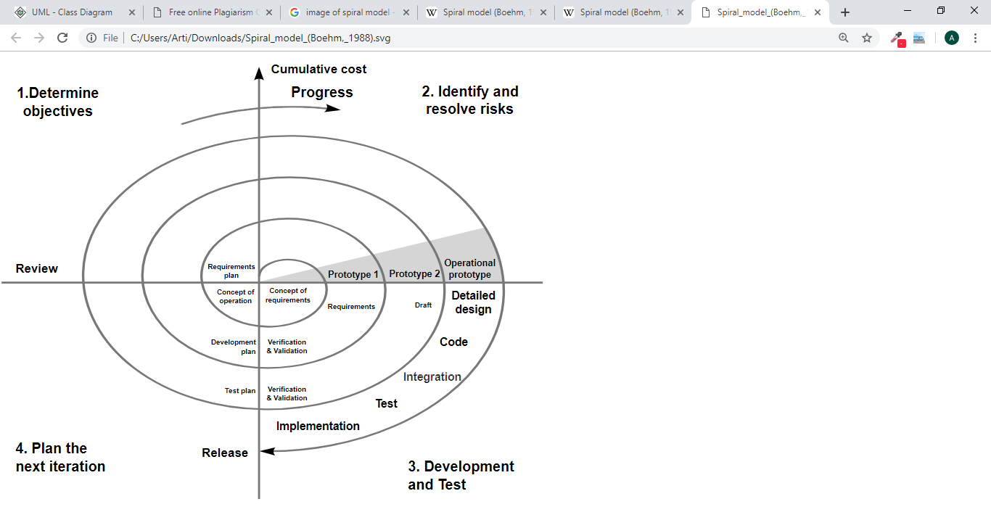

**Spiral Model**

As we know that it is combination of waterfall model also to be added on it. Because the same things in these both the type of the software process model is that the waterfall model we have to work in project requirement of the customer whichever he provides to us to be completed in the particular time period. That like that same working happen in the spiral model also but there is only one difference is that the working in the spiral model happens like that. The requirement of the customer can b change during the project time until it didn’t completed. But in waterfall model sequentially step by step working needed.

**Phases of spiral model**

**Planning:** All over the maintenance whatever is going to be done with our project is includes in planning. It also includes estimation of the projects going to complete the project in particular cost. Resources can also be identified by the planning before making the project of particular domain.

**Risk Analysis:** We can also identify the risks whatever we are going to take here in our project like applying a lot of cost in our project for making our particular project.

**Engineering:** The very important part of the planning phase which includes coding, testing and deploying the software.

**Evaluation:** Evolution of the project should be done before making the project. It is one of very important phase of the project that is very important to develop the project.

**Advantages:**

* More functionality or changes in the project can be done at a later stage will be more work for developer.
* Cost may be taken more after the changes applying.
* Continuously or again and again development helps in risk management in our project.
* Development of the project is too fast and more features are added in the systematic way.
* There will be always a field for customer feedback for the project

**Disadvantages:**

* Risk or budget may be change.
* Its working is very good for large projects for full filling the request of the customers. It demands risk assessment expertise in the projects.
* For the smooth operations of the project spiral model rules are needed to be followed.
* More documents will be needed to be authorized the project from the client side it.
* It is easy advisable to a developer, it might cost them a lot as compare to the previous one.

**3.2 Data Flow Diagram (DFD)**

A graphical tool used to describe and analyze the moment of data through a system manual or automated including the process, stores of data, and delays in the system. Data Flow Diagrams are the central tool and the basis from which other components are developed. The transformation of data from input to output, through processes, may be described logically and independently of the physical components associated with the system. The DFD is also know as a data flow graph or a bubble chart.

Data Flow Diagram provides a visual representation of the flow of our software information’s in the system. Also by looking this flow of the software band there working can easily be understood by the users and anyone. By drawing the Dataflow Diagram, you can tell the information provided by software to the users and delivered to someone who takes part in software processes, the information needs in order to complete the processes and information needed to be begun and executed it.

DFDs are the model of the proposed system. They clearly should show the requirements on which the new system should be built. Later during design activity this is taken as the basis for drawing the system’s structure charts.

**Types of DFD**

Data Flow Diagrams are either Logical or Physical.

* **Logical DFD** - This type of DFD concentrates on the system process, and flow of data in the system. For example in a Banking software system, how data is moved between different entities.
* **Physical DFD** - This type of DFD shows how the data flow is actually implemented in the system. It is more specific and close to the implementation.

**Levels of DFD**

* **Level 0** - Highest abstraction level DFD is known as Level 0 DFD, which depicts the entire information system as one diagram concealing all the underlying details. Level 0 DFDs are also known as context level DFDs.
* **Level 1** - The Level 0 DFD is broken down into more specific, Level 1 DFD. Level 1 DFD depicts basic modules in the system and flow of data among various modules. Level 1 DFD also mentions basic processes and sources of information. **Level 2** - At this level, DFD shows how data flows inside the modules mentioned in Level 1.
* Higher level DFDs can be transformed into more specific lower level DFDs with deeper level of understanding unless the desired level of specification is achieved.

**The Basic Notation used to create a DFD’s are as follows:**

**1. Dataflow:** Data move in a specific direction from an origin to a destination. It portrays the interface between the other components and is shown with arrows, typically labelled with a short data name, like “Billing details.”

**2. Process:** People, procedures, or devices that use or produce (Transform) Data. The physical component is not identified. It might perform computations, or sort data based on logic, or direct the data flow based on business rules. A short label is used to describe the process, such as “Submit payment.”

**3. Source:** External sources or destination of data, which may be People, programs, organizations or other entities. They are the sources and destinations of information entering or leaving the system. They might be an outside organization or person, a computer system or a business system. They are also known as terminators, sources and sinks or actors. They are typically drawn on the edges of the diagram.

**4. Data Store:** Here data are stored or referenced by a process in the System.  Files or repositories that hold information for later use, such as a database table or a membership form. Each data store receives a simple label, such as “Orders.”

**How to create a data flow diagram**

Now that you have some background knowledge on data flow diagrams and how they are categorized, you’re ready to build your own DFD. The process can be broken down into 5 steps:

**1. Identify major inputs and outputs in your system**

Nearly every process or system begins with input from an external entity and ends with the output of data to another entity or database. Identifying such inputs and outputs gives a macro view of your system—it shows the broadest tasks the system should achieve. The rest of your DFD will be built on these elements, so it is crucial to know them early on.

**2. Build a context diagram**

Once you’ve identified the major inputs and outputs, building a context diagram is simple. Draw a single process node and connect it to related external entities. This node represents the most general process information undergoes to go from input to output.

The example below shows how information flows between various entities via an online community. Data flows to and from the external entities, representing both input and output. The centre node, “online community,” is the general process.

**3. Expand the context diagram into a level 1 DFD**

The single process node of your context diagram doesn’t provide much information- you need to break it down into sub processes. In your level 1 data flow diagram, you should include several process nodes, major databases, and all external entities. Expand the all activities of level-0 DFD and show the sub-processes of main processes that contains in level-0 dataflow diagram. Level 1 DFD contains almost all processes that execute in a project.

**Level-0 DFD of PMT:** In the zero level dataflow diagram of Project Management Tool I show that the main modules that can manage Project Management Tool. It shows the flow processes of admin, project manager, developer and clients. This diagram represents the flow of Admin activities, manager activities, developer, activities and client activities. Some inputs are goes into Project Management Tool by main entities and Project Management Tool give output to entities according to the input. All the process that will run in an organization related to software development are handled by the PMT like- firstly client give required information to PMT registration and after that this data show to admin and after admin take the next action for client that can be either permit to post project further or denied to post project. According to the admin permission client will post project in PMT and this project can view by admin after that this project can assign to the project manager by the admin and when admin approve to project manager then assigned project viewed by the admin.

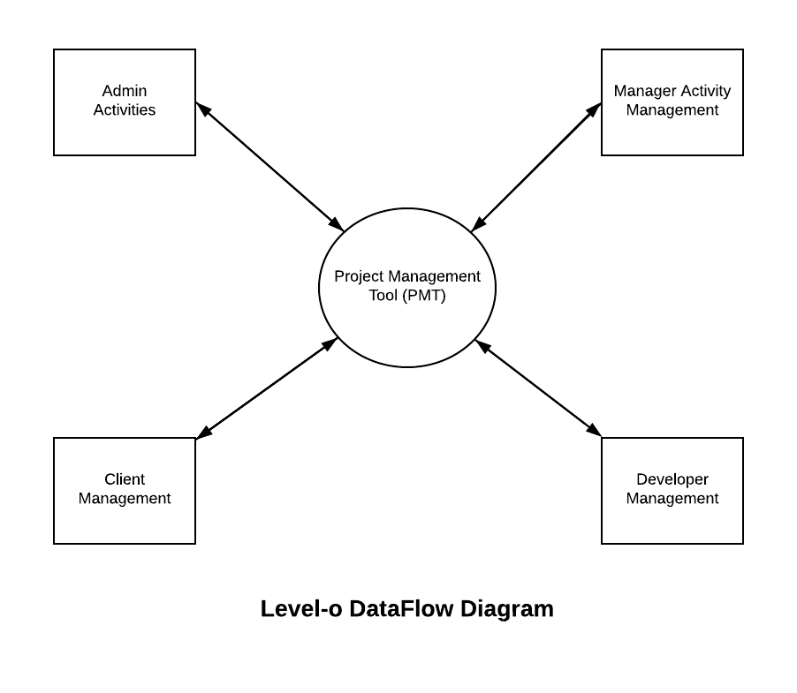

**Fig 3.2.1 Level-0 DFD of PMT**

**Level-1 DFD for Admin:** This DFD show the all the activities that can run under the admin.

This contains all the processes that handled by the admin like- Client Management, Project Management, and Employee Management. Like Admin can approve and block to the client and approve and block to the project manager and developer and project after the permission of the admin client, manager and employee can do their work further. Admin can view the feedbacks of clients and daily work reports of projects and projects status. Feedback fetch from the database and view to the admin and this feedback can manage by the admin. Since daily work report manage into database so when required to see daily work report and status of the project fetched from the database and show to the admin. Such that project status view by admin from the database. Admin has all rights to handle all the persons in the organization.

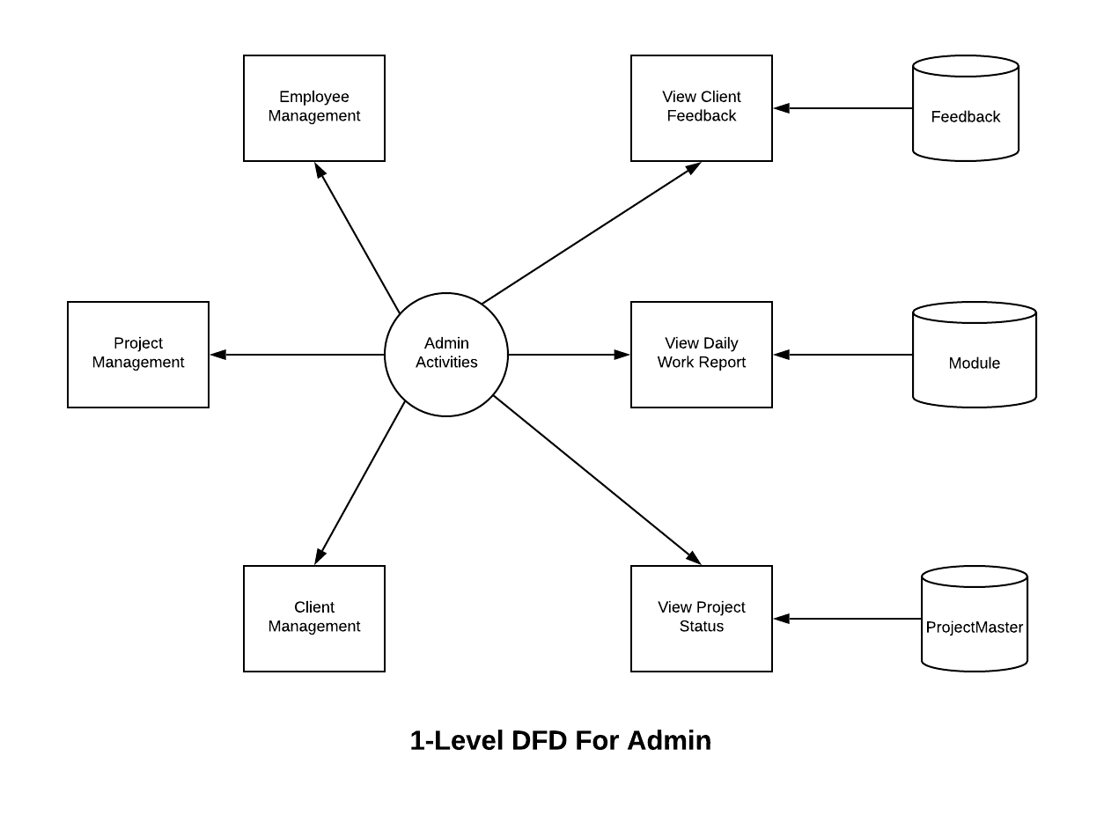

**Fig 3.2.2 Level-1 DFD for Admin**

**Level-1 DFD for Manager:** This DFD shows the flow of manager activities inside project management tool. Manager view their own project and divide the project into modules these modules assigned to the developer for development for this all the records stored into the database manager assign the module to the developer and if approve to the developer then developer can see their module. After the development of the module developer feed the module work daily to daily. Finally manager also feed the daily to daily project work and the work report can view by the admin.

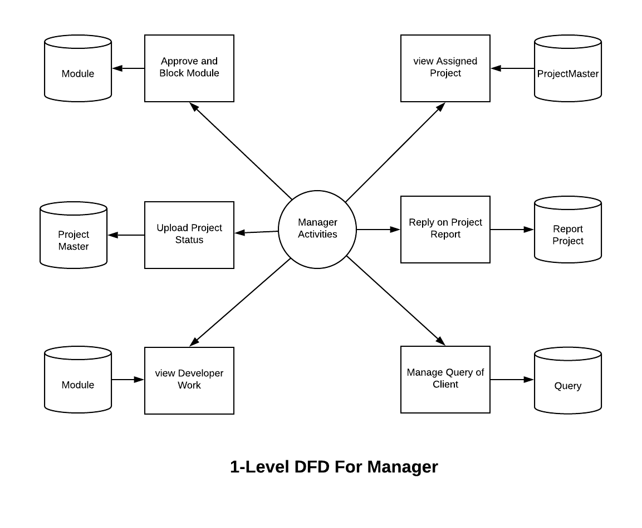

**Fig 3.2.3 Level-1 DFD for Manager**

**Level-1 DFD for Developer:** This DFD show the flow developer activities in project management tool**.** Developer can view their module after the permission of the project manager after that he can develop that module and fee daily work report of module that store into the database and later this can viewed by the project manager. If developers have any doubt about the module then developer can asks to the manager and manger reply can view by the developer such that overall all the activities related to the project development in a development company are mange under the Project Management Tool. Developer can also see their completed modules in Project Management Tool.

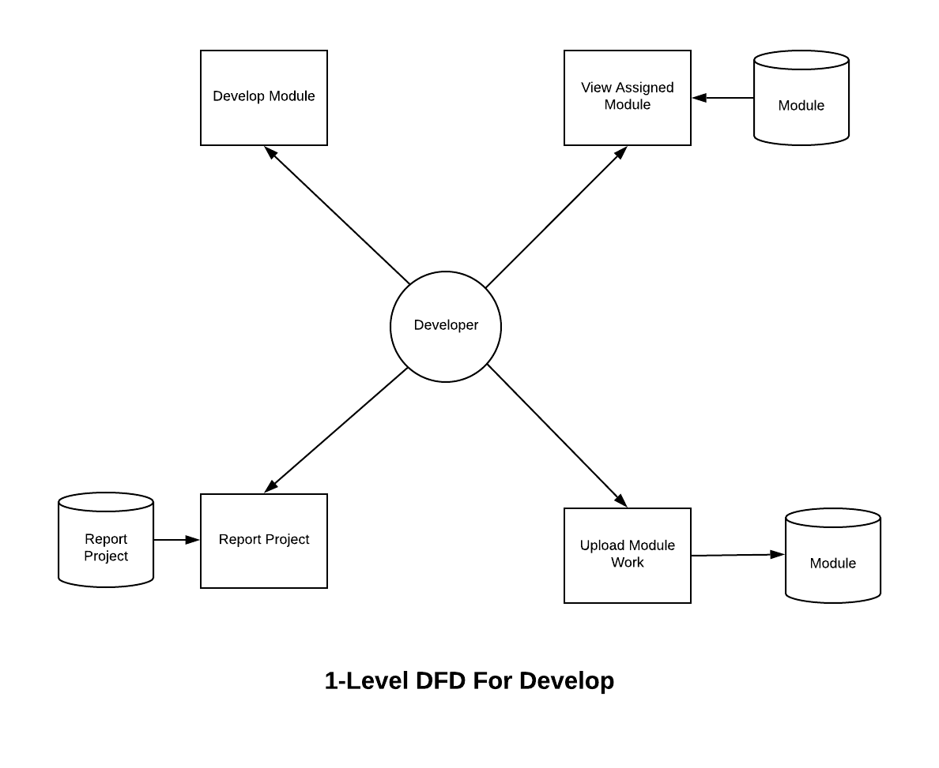

**Fig 3.2.4 Level-1 DFD for Developer**

**Level-1 DFD for Client:**  All the activities of the project client in Project Management Tool are shown in following DFD. A client can give their information for registration that will store into the database by the help of Project Management Tool. After registering the client admin give the permission to the client to post their project then client can post their project to the Project Management Tool by giving all the information related to the project, these information’s store into the database and these information can viewed by the admin. Client can also give the feedback by the help of Project Management Tool by this client can share their experience about the company. Client can query to the project manager that handle their project if wants to add any extra requirement or if client has any doubt about their project. He can see their project status or working of the project during the development by the permission of the client.

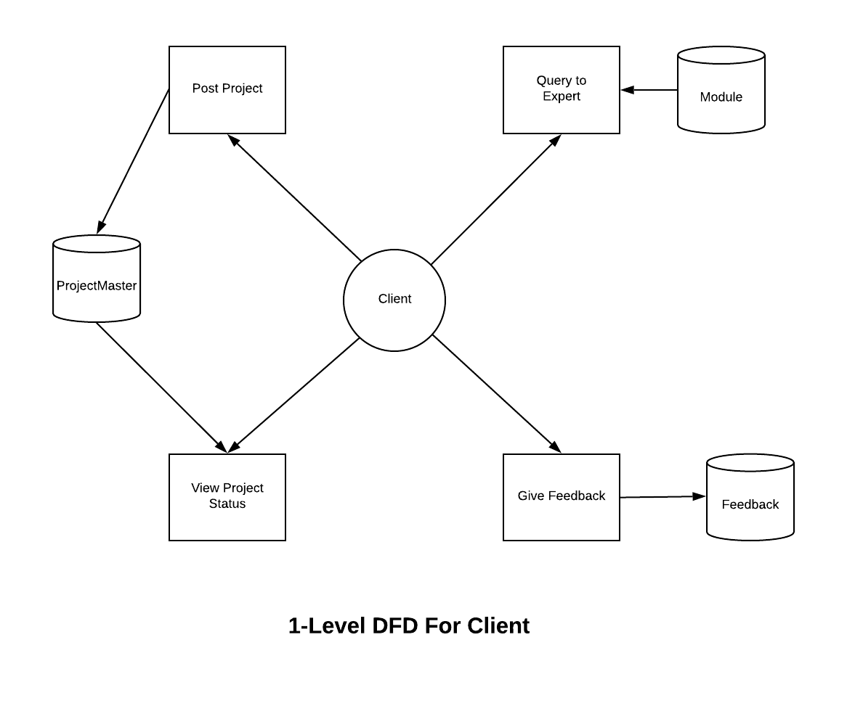

**Fig 3.2.5 Level-1 DFD for Client**

**3.3 ER-Diagram**

An entity relationship model, also called an entity-relationship (ER) diagram, is a graphical representation of entities and their relationships to each other, typically used in computing in regard to the organization of [data](https://www.webopedia.com/TERM/D/data.html) within [databases](https://www.webopedia.com/TERM/D/database.html) or information systems. An entity is a piece of data-an [object](https://www.webopedia.com/TERM/O/object.html)or concept about which data is stored.

Entity relationship model is known as entity relationship diagram too, is a graphical representation of entities of our projects table and their relationships to each other in the table, used in computing in to the organization of [data](https://www.webopedia.com/TERM/D/data.html) with [databases](https://www.webopedia.com/TERM/D/database.html) or information systems of the project. An entity is a piece of data [object](https://www.webopedia.com/TERM/O/object.html)or concept about which data is stored in the tables of our software. ER model places very good representation diagrammatically very effective to be applying and visualize logical structure of database. By watching ER diagram, we can easily be understood the relationship among entities and relationship.

[Peter Chen](https://en.wikipedia.org/wiki/Peter_Chen) is credited with introducing the widely adopted ER model in his paper “[The Entity Relationship Model-Toward a Unified View of Data](http://www.csc.lsu.edu/~chen/pdf/erd-5-pages.pdf)“. The focus was on entities and relationships and he introduced a diagramming representation for database design as well.

His model was inspired by the data structure diagrams introduced by Charles Bachman. One of the early forms of ER diagrams, Bachman diagrams are named after him.

**Components:**

#### Entity

An entity can be a person, place, event, or object that is relevant to a given system.

#### Weak Entity

A weak entity is an entity that depends on the existence of another entity. In more technical terms it can be defined as an entity that cannot be identified by its own attributes.

#### Attribute

An attribute is a property, trait, or characteristic of an entity, relationship, or another attribute. For example, the attribute Inventory Item Name is an attribute of the entity Inventory Item. An entity can have as many attributes as necessary.

#### Multivalued Attribute

If an attribute can have more than one value it is called a multi-valued attribute. It is important to note that this is different from an attribute having its own attributes.

#### Derived Attribute

An attribute based on another attribute. This is found rarely in ER diagrams. For example, for a circle, the area can be derived from the radius.

**Relationship**

A relationship describes how entities interact. For example, the entity “Carpenter” may be related to the entity “table” by the relationship “builds” or “makes”.

#### Recursive Relationship

If the same entity participates more than once in a relationship it is known as a recursive relationship. In the below example an employee can be a supervisor and be supervised, so there is a recursive relationship.

[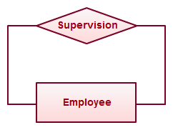](https://d3n817fwly711g.cloudfront.net/blog/wp-content/uploads/2012/03/Recursive-Relationship-ER-Diagrams.jpeg)

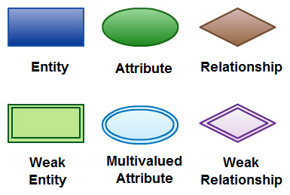

**Components of ER- Diagram**

**ER-Diagram of Project Management Tool:**  Following is the ER-diagram of the project management tool that shows the all the entities that are involved in the Project Management Tool, how these are relate to each other. The main entities are Admin, Employee, Client, ProjectMaster and Query. Admin is the super entity that relate to the all the other entities such that admin can access all the entities records. The underlined attribute show the primary key into the entity and diamond shape show the relationship between the two entities. Employee is relates to the ProjectMaster and Client so employees have access to the Project Master and Client but after the permission of the Admin. The primary key of entities Employee and Client make as foreign key in ProjectMaster Entity, such Employee and Client both can access records of ProjectMaster Entity after the permission of the admin. The primary column of the Client entity and Employee entity made as foreign key column Query entity such that Client and Employee both can communicate with Query entity. Such all other relationships clear in following diagram.

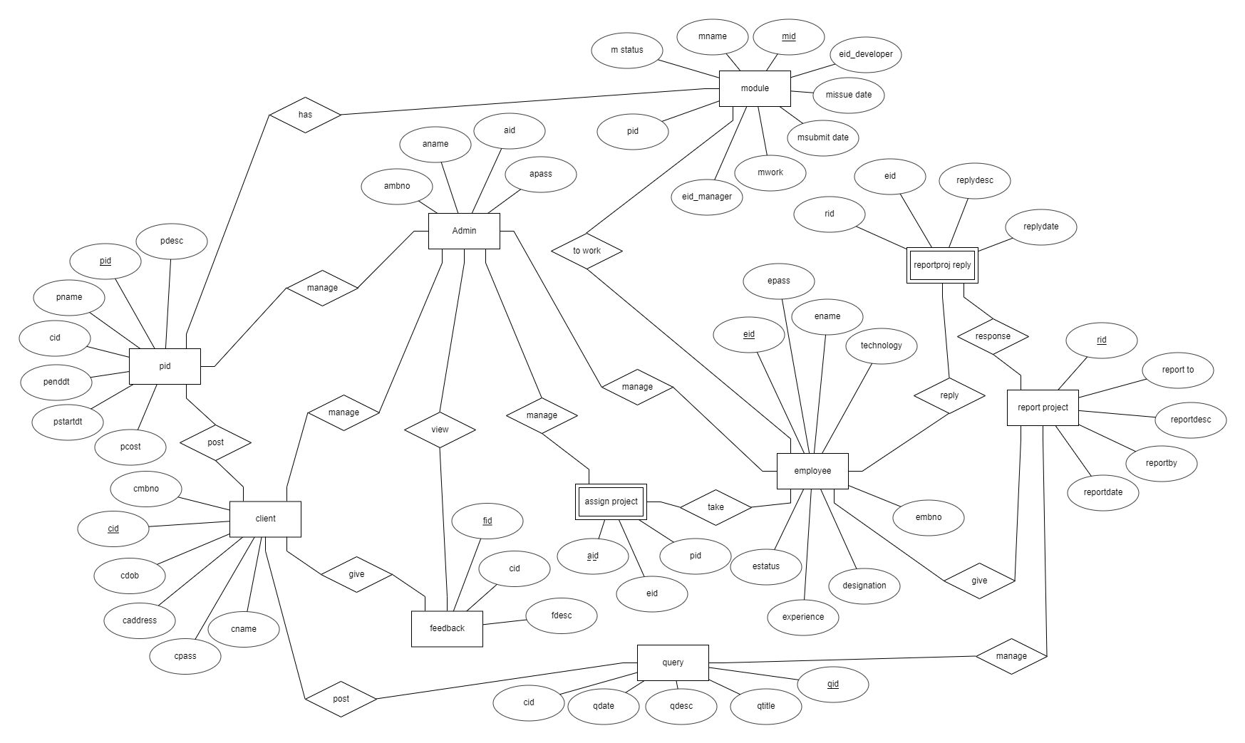

**Fig 3.3.1 ER-Diagram of Project Management Tool**

**3.4 Activity Diagram**

Activity diagram is basically a flowchart to represent the flow from one activity to another activity. The activity can be described as an operation of the system.

It captures the dynamic behaviour of the system. Other four diagrams are used to show the message flow from one object to another but activity diagram is used to show message flow from one activity to another.

Activity is a particular operation of the system. Activity diagrams are not only used for visualizing the dynamic nature of a system, but they are also used to construct the executable system by using forward and reverse engineering techniques.

**Symbols of Activity diagram:**

#### Start/End Symbol

The terminator symbol marks the starting or ending point of the system. It usually contains the word "Start" or "End."

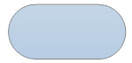

#### Action or Process Symbol



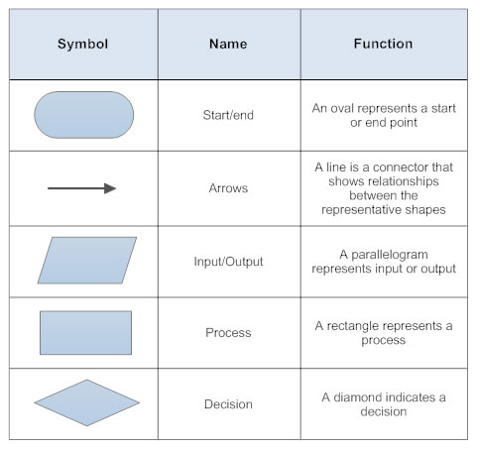

**Flowchart Diagram Symbols**

Before drawing an activity diagram, we must have a clear understanding about the elements used in activity diagram. The main element of an activity diagram is the activity itself. An activity is a function performed by the system. After identifying the activities, we need to understand how they are associated with constraints and conditions.

Before drawing an activity diagram, we should identify the following elements −

* Activities
* Association
* Conditions
* Constraints

**Activity Diagram of PMT:** Following diagram is the activity diagram of Project Management Tool. This shows the overall flow of Project Management Tool, in that any type of user like- client, employee and admin first of all have to login after that can perform any type of activities.

In Project Management Tool if any user login then first checked that which type of user is try to login after identification of user will be login and views their own working dashboard on which user can perform their own activities according to role of the user.

If login user is client type then he can perform following activities- client can post their project into Project Management Tool according the admin permission. Client does all activities according to the admin permission. Client can view their project status if approved and also can post their query to project manager that handle their project. This query can view manager and can give reply and this reply can view by the client of the project.

If login user is employee then can perform all activities that are related to the project in a company. Means if employee is manger then he can see their own assigned project on the manager dashboard, manager can approve and block the modules for the developer and also can see the project module work status. If employee is a developer then he can see their own assigned module if has manger permission then developer feed the work report to the Project Management Tool and if has any doubt then he can asks to their own manager. Work reports that given by the developer can see manager if all is correct then manger upload the work status to the Project Management Tool and this final report can see admin and if admin permit to the client then client can see their own project status.

If login user is Admin the can handle all the activities that can be done by the Project Management Tool. Admin can tract to all either client or employees. Admin approved clients, managers, developers and projects after that any user (client, manger, developer) can perform their own activities such that admin has all the rights related to project development.



**Fig 3.4.1 Activity Diagram of Project Management Tool**

**3.5 Use case Diagram**

A use case diagram is a type of UML diagram. It is dynamic or behaviour diagram in [UML](https://www.smartdraw.com/uml-diagram/). Use case diagrams show the functionality of a system using actors and use cases in the form of model. Set of actions, services, and functions that the system needs to perform are called use cases. By this a "system" is something being developed or operated, such as a web site. The people or entities operating under defined roles within the system are called actors.

**Importance of Usecase diagram:**

Use case diagrams are valuable for visualizing the functional requirements of a system that will translate into design choices and development priorities.

They also help identify any internal or external factors that may influence the system and should be taken into consideration.

They provide a good high level analysis from outside the system. Use case diagrams specify how the system interacts with actors without worrying about the details of how that functionality is implemented.

**Usecase diagram symbols:**

**System**   
System boundary is draw using rectangular block and place the actors outside of the class and place the Usecase inside the block. A system represents the whole Usecase that shows relationships between the actors and Usecase.

System Name

**Usecase**   
Use case is draw using oval shapes and label the ovals with verbs that represent the system's functions. Use case always put inside the boundary system and the Usecase connected with the actors by the help of arrows that shows the relationship.

**Actors**   
The user of the system is an actor. Put the actor outside the system and connect actors with Usecase according to the Usecase. Actor is used to show the activity of the system according to Usecase. Arrow is used to connect actor with the Usecase thus arrow shows the relationship between the actors ns use cases. An actor can be a person, an organization, or an outside system that interacts with the application or system. Actors must be external objects that give data and take data.

Actor

**Relationships**   
To make the relationship between an actor and a use case use a simple line. An "extends" relationship indicates alternative options under a certain use case. For relationships between use cases, use arrows labelled either "uses" or "extends." A "uses" relationship indicates that one use case is needed by another use case to perform a task.

<<Include>>

<<Exclude>>

**Usecase Diagram PMT:**

Following diagram is the Usecase diagram of Project Management Tool. It contains 4 actors, 14 use cases and 14 sub-use cases, and many relationships that form the Usecase of PMT together. The actors are admin, manager, developer and clients.

This contains all the processes that handled by the admin like- Client Management, Project Management, and Employee Management. Like Admin can approve and block to the client and approve and block to the project manager and developer and project after the permission of the admin client, manager and employee can do their work further. Admin can view the feedbacks of clients and daily work reports of projects and projects status. Feedback fetch from the database and view to the admin and this feedback can manage by the admin. Since daily work report manage into database so when required to see daily work report and status of the project fetched from the database and show to the admin. Such that project status view by admin from the database. Admin has all rights to handle all the persons in the organization.

Manager view their own project and divide the project into modules these modules assigned to the developer for development for this all the records stored into the database manager assign the module to the developer and if approve to the developer then developer can see their module. After the development of the module developer feed the module work daily to daily. Finally manager also feed the daily to daily project work and the work report can view by the admin.

Developer can view their module after the permission of the project manager after that he can develop that module and fee daily work report of module that store into the database and later this can viewed by the project manager. If developers have any doubt about the module then developer can asks to the manager and manger reply can view by the developer such that overall all the activities related to the project development in a development company are mange under the Project Management Tool. Developer can also see their completed modules in Project Management Tool.

A client can give their information for registration that will store into the database by the help of Project Management Tool. After registering the client admin give the permission to the client to post their project then client can post their project to the Project Management Tool by giving all the information related to the project, these information’s store into the database and these information can viewed by the admin. Client can also give the feedback by the help of Project Management Tool by this client can share their experience about the company. Client can query to the project manager that handle their project if wants to add any extra requirement or if client has any doubt about their project.



**Fig 3.5.1 Usecase Diagram of Project Management Tool**

**3.6 Sequence Diagram**

Sequence diagram is a type of interaction diagram that describes how to work the group of objects together and in what order they are work. Sequence diagrams are used by software developers and business professionals to understand requirements for a new system.

**Advantages of sequence diagram**

Sequence diagram is references for businesses and other organizations. There are many advantages of sequence diagram like following:

* It represents the details of a use case diagram.
* It is used to model the logic of a sophisticated procedure, function, or operation.
* By the help of sequence diagram you can see how objects and components interact with each other to complete a process.
* Sequence diagram plan and understand the detailed functionality of an existing or future scenario.

**Symbols used for Sequence Diagram:**

**Object Symbol:** Represents a class or object in UML. The object symbol demonstrates how an object will behave in the context of the system.

**Activation Box:** Represents the time needed for an object to complete a task. The longer the task will take, the longer the activation box becomes.

**Actor Symbol:** Shows entities that interact with or are external to the system.

Actor

**Lifeline Symbol:** Represents the passage of time as it extends downward.

: User

**Sequence Diagram for Admin:**

This contains all the processes that handled by the admin like- Client Management, Project Management, and Employee Management. Like Admin can approve and block to the client and approve and block to the project manager and. Admin can view the feedbacks of clients and daily work reports of projects and projects status. Since daily work report manage into database so when required to see daily work report and status of the project fetched from the database and show to the admin. Such that project status view by admin from the database. Admin has all rights to handle all the persons in the organization.

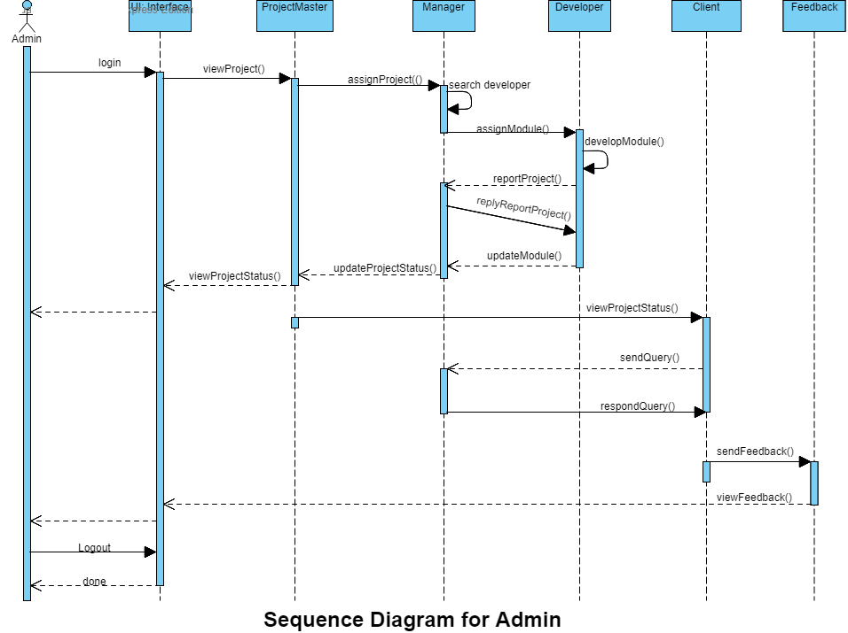

**Fig 3.6.1 Sequence Diagram for Admin**

**Sequence Diagram for Client:**

A client can give their information for registration that will store into the database by the help of Project Management Tool. After registering the client admin give the permission to the client to post their project then client can post their project to the Project Management Tool . A client can give their information for registration that will store into the database by the help of Project Management Tool. After registering the client admin give the permission to the client to post their project then client can post their project to the Project Management Tool by giving all the information related to the project, these information’s store into the database and these information can viewed by the admin. Client can also give the feedback by the help of Project Management Tool by this client can share their experience about the company. Client can query to the project manager that handle their project if wants to add any extra requirement or if client has any doubt about their project.

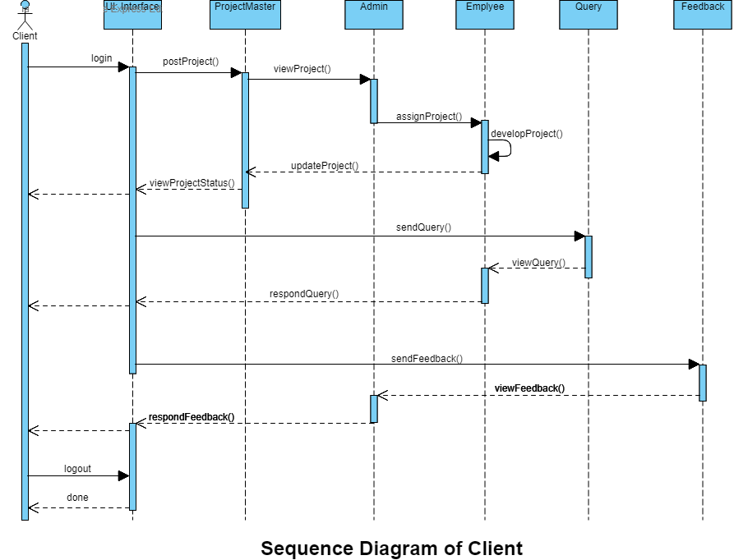

**Fig 3.6.2 Sequence Diagram for Client**

**3.7 Class Diagram**

The attributes and operations of a class and also the constraints imposed on the system described by Class diagram. Class diagrams are used in the modelling of object-oriented systems because they are the only UML diagrams, which can be mapped directly with object-oriented languages.

It shows a collection of classes, interfaces, associations, collaborations, and constraints. Class diagrams also known as a structural diagram.

The main purposes of class diagram are as following:

* It is used for analysis and design of the static view of an application that clear the view of an application.
* It describes responsibilities of a system that are necessary for a system.
* It is the base for component and deployment diagrams that are used in project development. The component and deployment diagrams are more important for project development process.

## Steps to draw Class Diagram

Class diagram has a lot of properties that is to consider while drawing but here the diagram will be considered from a top level view. The Class diagram is basically a graphical representation of the static view of the system and represents different aspects of the application. The whole system represented by the collections of class diagrams. Class Diagram is most important component to understand any project.

The following points remembered during the creation of class diagram:

* Class diagram should be meaningful to describe the aspect of the system.
* In class diagram each element and their relationships should be identified in advance.
* In class diagram attributes and methods of each class should be clearly identified.
* In class diagram, for each class, minimum number of properties should be specified, as unnecessary properties will make the diagram complicated.
* In class diagram, use notes whenever required to describe some aspect of the diagram. At the end of the drawing it should be understandable to the developer in any software company.

**Class Diagram of Project Management Tool:**

Following diagram is the class diagram of Project Management Tool that represents the all classes that are used in Project Management Tool. There are 10 classes which are ProjectMaster, Admin, AssignProject, Employee, Module, Admin, Query, Client, Feedback, ReplyQuery, ReportQuery and ProjectReportReply class. These all classes responsible to manage all the activities of project management tool by the help of methods that contains inside these classes. The following diagram also shows the relationship between the class means it shows that how these classes are related to each other. This diagram also shows that how one class is dependent on another class. In the following diagram filled arrow shows the that one class is fully dependent on another class and unfilled arrow shows the partial dependency of the one class to the another class and the relationship between classes can be one to many, many to one, one to one, many to many or zero to one.

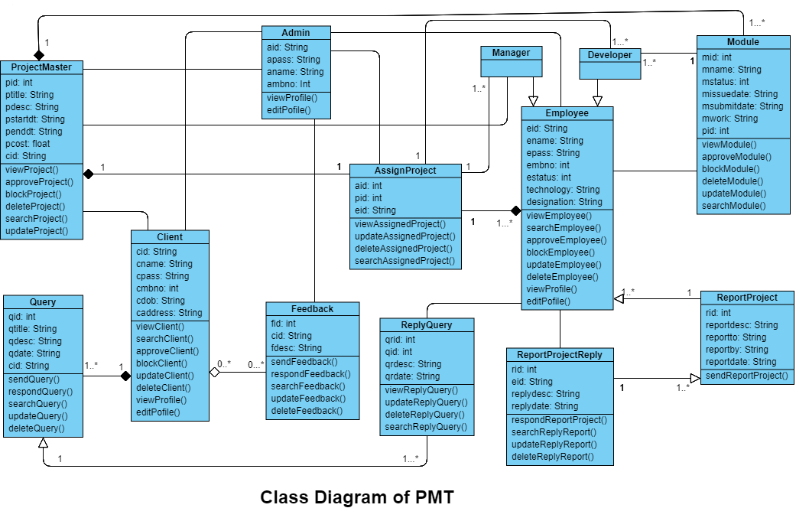

**Fig 3.7.1 Class Diagram of Project Management Tool**

**3.8 Database Tables**

**Admin Table:**

Following table is the table of admin of Project Management Tool. This table contains a primary key “aid” that is admin user id by which admin can login to perform all their activities. There are three columns other than the primary key column that are “apass” that can manage the password of admin and “aname” ” that can manage the name of admin and “ambno” ” that can manage the Mobile number of the admin. “aid” column can’t be null because this is primary key column means admin password can’t be null and duplicate.

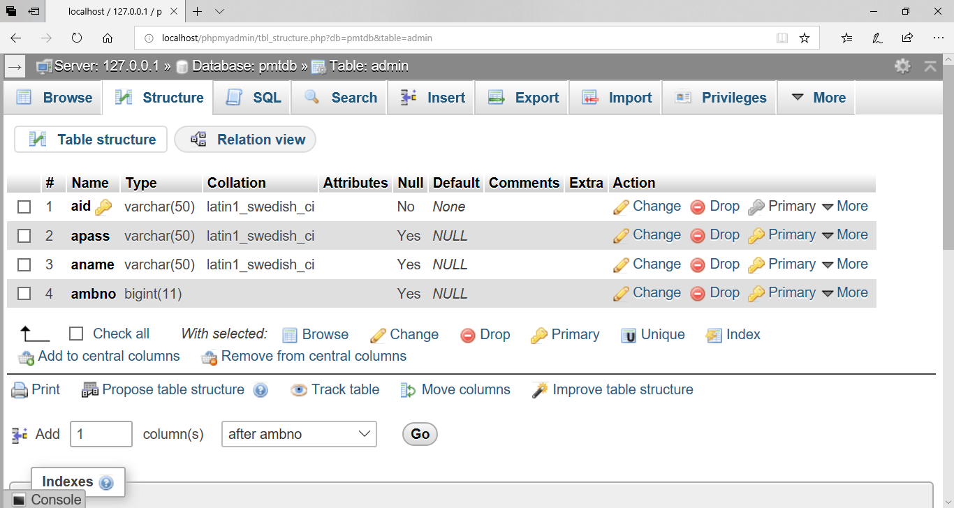

**Fig 3.8.1 Table for Admin of PMT**

**Client Table:**

Following table is the table for client of Project Management Tool. This table contains a primary key “cid” that is client user id by which client can login to perform all their activities. There are seven columns other than the primary key column that are “cpass” that can manage the password of client and “cname” that can manage the name of client and “cmbno” ” that can manage the Mobile number of the client and “caddress” manages the address of the client and “cregdt” for client registration date and cgender to store the gender of the client and finally one more extra column “caprstatus” also included that is for client status this column is most important column it manage the clients to perform activities.

The client can be block or approved, if “caprstatus” value is 2 then client is blocked, if “caprstatus” value is 1 then client is approve in this case client can perform their own activities if “caprstatus” value is zero that means corresponding client is new in Project Management Tool. So, all activities of client depend on the value of the “caprstatus “column. The “cid” column can’t be null because this is primary key column means client password can’t be null and duplicate.

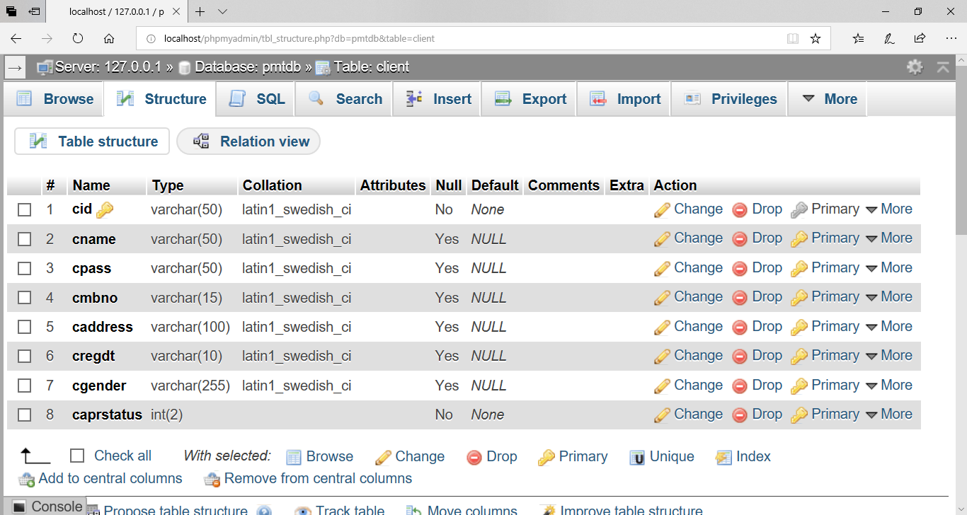

**Fig 3.8.2 Table for Client of PMT**

**Employee Table:**

Following table is the table for Employee of Project Management Tool. This table contains a primary key “eid” that is Employee user id by which Employee can login to perform all their activities. There are eight columns other than the primary key column that are “epass” that can manage the password of Employee and “ename” that can manage the name of Employee and “embno” that can manage the Mobile number of the Employee and “Technology” manages the field of skill of the Employee and “eregdt” for Employee registration date and “designation” to store the type of the employee and “egender” to store the gender of the Employee and finally one more extra column “estatus” also included that is for Employee status this column is most important column it manage the Employees to perform activities.

The Employee can be block or approved, if “estatus” value is 2 then Employee is blocked, if “estatus” value is 1 then Employee is approve in this case Employee can perform their own activities if “estatus” value is zero that means corresponding Employee is new in Project Management Tool. So, all activities of Employee depend on the value of the “estatus” column. The “eid” column can’t be null because this is primary key column means Employee password can’t be null and duplicate.

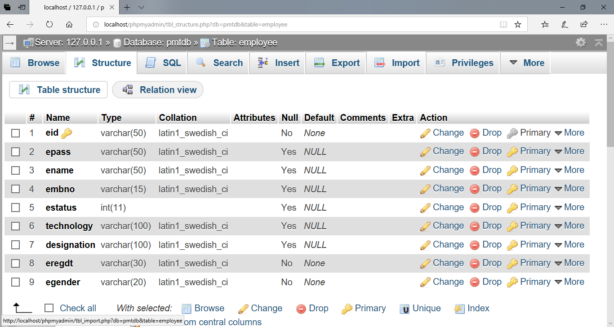

**Fig 3.8.3 Table for Employee of PMT**

**ProjectMaster Table:**

Following table is the table for Project of Project Management Tool. This table contains a primary key “pid” that is Project id by which Project can identified for all their activities. There are eleven columns other than the primary key column that are “ptitle” that can manage the title of Project and “pdesc” that can manage the description of Project and “passigndt” that can manage the assignment date of the Project and “psubdt” manages the submission date of the Project and “pcost” for Project cost and “pwork” to store the percentage of work of the Project and “pdeldt” to store the delete date of the Project and one extra column “pstatus” also included that is for Project status this column is most important column it manage the Projects to perform activities related to project devlopment.

The Project can be block or approved, if “pstatus” value is 2 then Project is blocked, if “pstatus” value is 1 then Project is approve in this case Project can access to perform activities related to development, if “pstatus” value is zero that means corresponding Project is new in Project Management Tool. So, all activities of Project depend on the value of the “pstatus” column. The “pid” column can’t be null because this is primary key column means Project id can’t be null and duplicate. There is two more column that are “eid” and “cid” that make as foreign key column in which “eid” references to the Employee table primary column and “cid ” references to the Client table primary column. Since “eid” and “cid” column of ProjectMaster table made as foreign key column the value of these column can’t be null but can be duplicate.

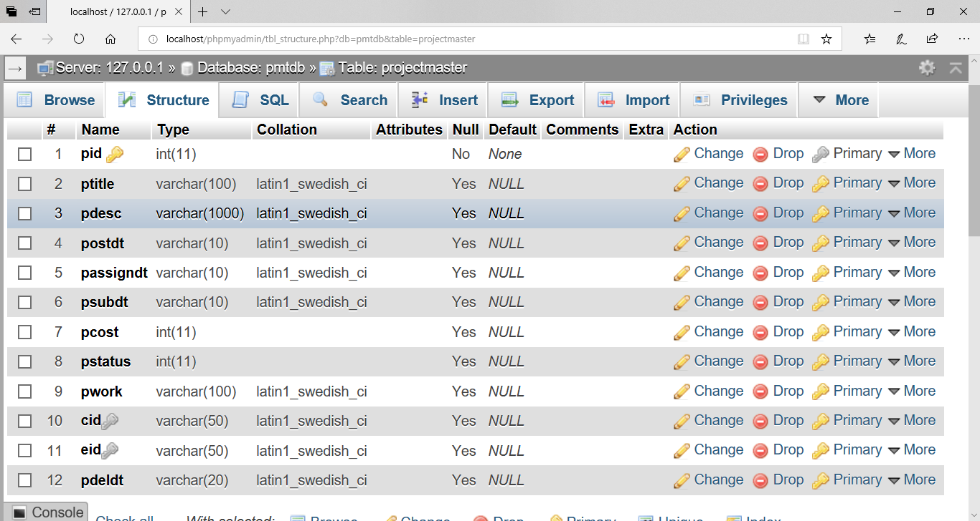

**Fig 3.8.4 Table for ProjectMaster of PMT**

**Module Table:**

Following table is the table for Module of Project Management Tool. This table contains a primary key “mid” that is Module id by which Module can identify for all their activities. There are six columns other than the primary key column that are “mname” that can manage the name of the Module and “mdesc” that can manage the description of Module and “massigndt” that can manage the assignment date of the Module and “msubdt” manages the submission date of the Module and “pwork” to store the percentage of work of the Module and one extra column “mstatus” also included that is for Module status this column is most important column it manage the Modules to perform activities related to Module devlopment.

The Module can be block or approved, if “mstatus” value is 2 then Module is blocked, if “mstatus” value is 1 then Module is approve in this case Module can access to perform activities related to development, if “mstatus” value is zero that means corresponding Module is new in Project Management Tool. So, all activities of Module depend on the value of the “mstatus” column. The “mid” column can’t be null because this is primary key column means Module id can’t be null and duplicate. There is two more column that are “pid” and “eid” that make as foreign key column in which “pid” references to the ProjectMaster table primary column and “eid” references to the Employee table primary column. Since “pid” and “eid” column of Module table made as foreign key column the value of this column can’t be null but can be duplicate.

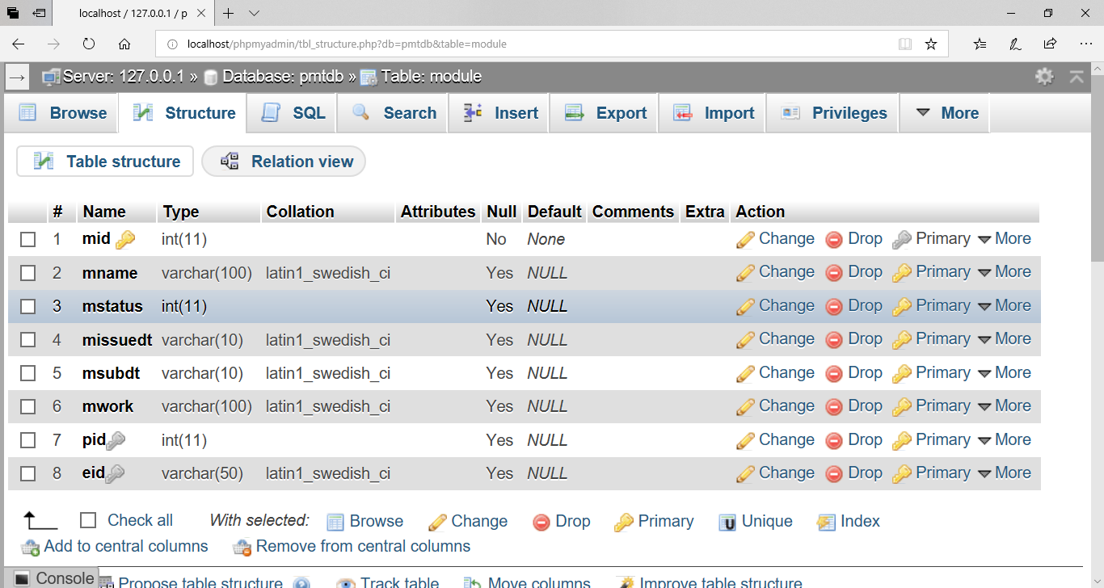

**Fig 3.8.5 Table for Module of Project**

**Feedback Table:**

Following table is the table for Feedback of Project Management Tool. This table contains a primary key “fid” that is Feedback id by which Feedback can identify for all their activities. There are four columns other than the primary key column that are “fdesc” that can manage the description of Feedback and “fdt” that can manage the sending date of the Feedback and “freply” manages the reply date of the Feedback.

The “fid” column can’t be null because this is primary key column means Feedback id can’t be null and duplicate. There is one more column that are “eid” that make as foreign key column in which “eid” references to the Employee table primary column. Since “eid” column of Feedback table made as foreign key column the value of this column can’t be null but can be duplicate.

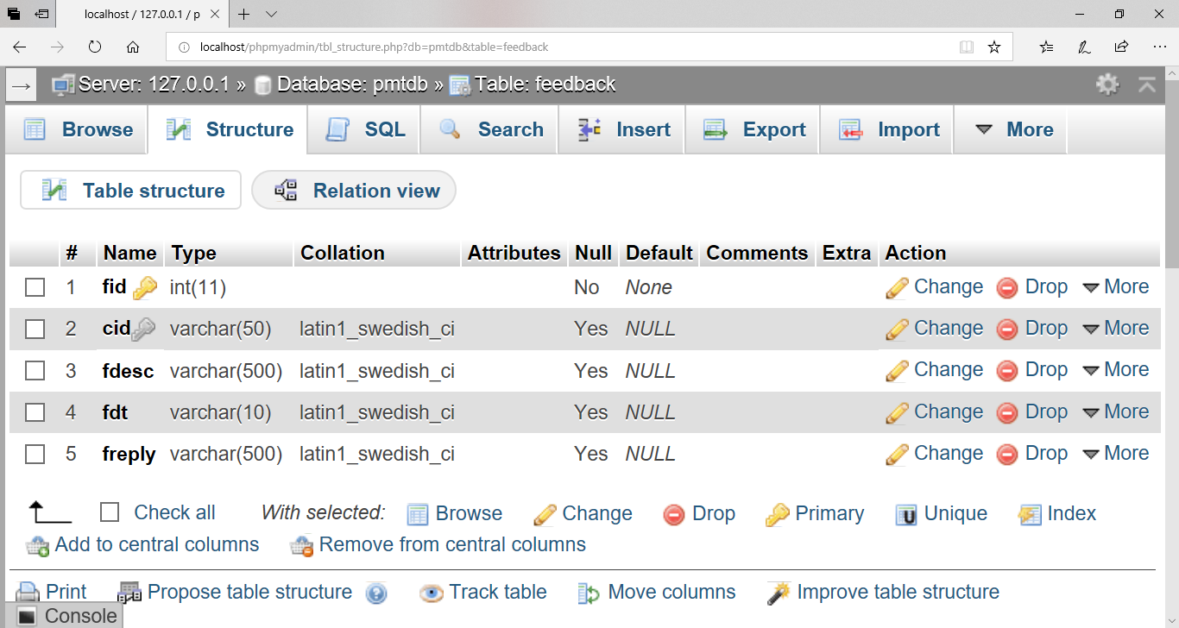

**Fig 3.8.6 Table for Feedback of Employee**

**Query Table:**

Following table is the table for Query of Project Management Tool. This table contains a primary key “qid” that is Query id by which Query can identify for all their activities. There are four columns other than the primary key column that are “qdesc” that can manage the description of Query and “qdt” that can manage the sending date of the Query

The “qid” column can’t be null because this is primary key column means Query id can’t be null and duplicate. There is one more column that are “cid” that make as foreign key column in which “cid” references to the Client table primary column. Since “cid” column of Query table made as foreign key column the value of this column can’t be null but can be duplicate.

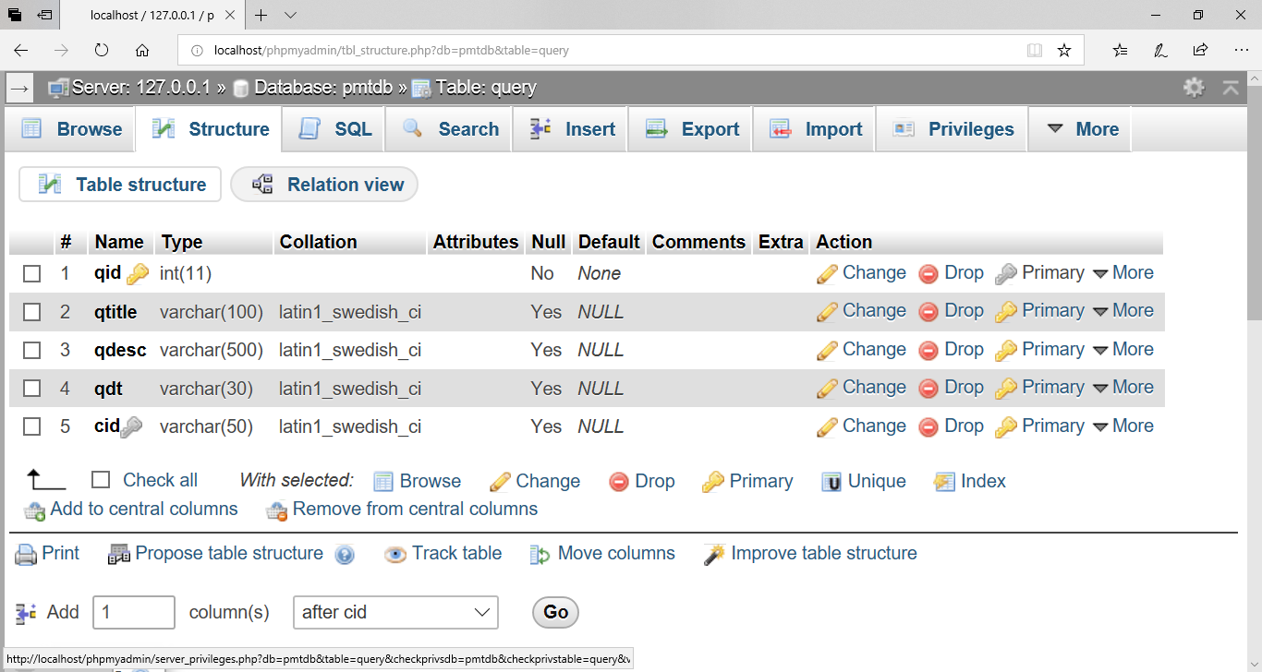

**Fig 3.8.7 Table for Query of Client**

**QueryReply Table:**

Following table is the table for Reply of Query in Project Management Tool. This table contains a primary key “qrid” that is QueryReply id by which QueryReply can identify for all their activities. There are three columns other than the primary key column that are “qrdesc” ”that can manage the description of QueryReply and “qrdt” that can manage the sending date of the QueryReply on which manager reply of the query.

The “qrid” column can’t be null because this is primary key column means QueryReply id can’t be null and duplicate. There is one more column that are “qid” that make as foreign key column in which “qid” references to the Query table primary column. Since “qid” column of QueryReply table made as foreign key column the value of this column can’t be null but can be duplicate.

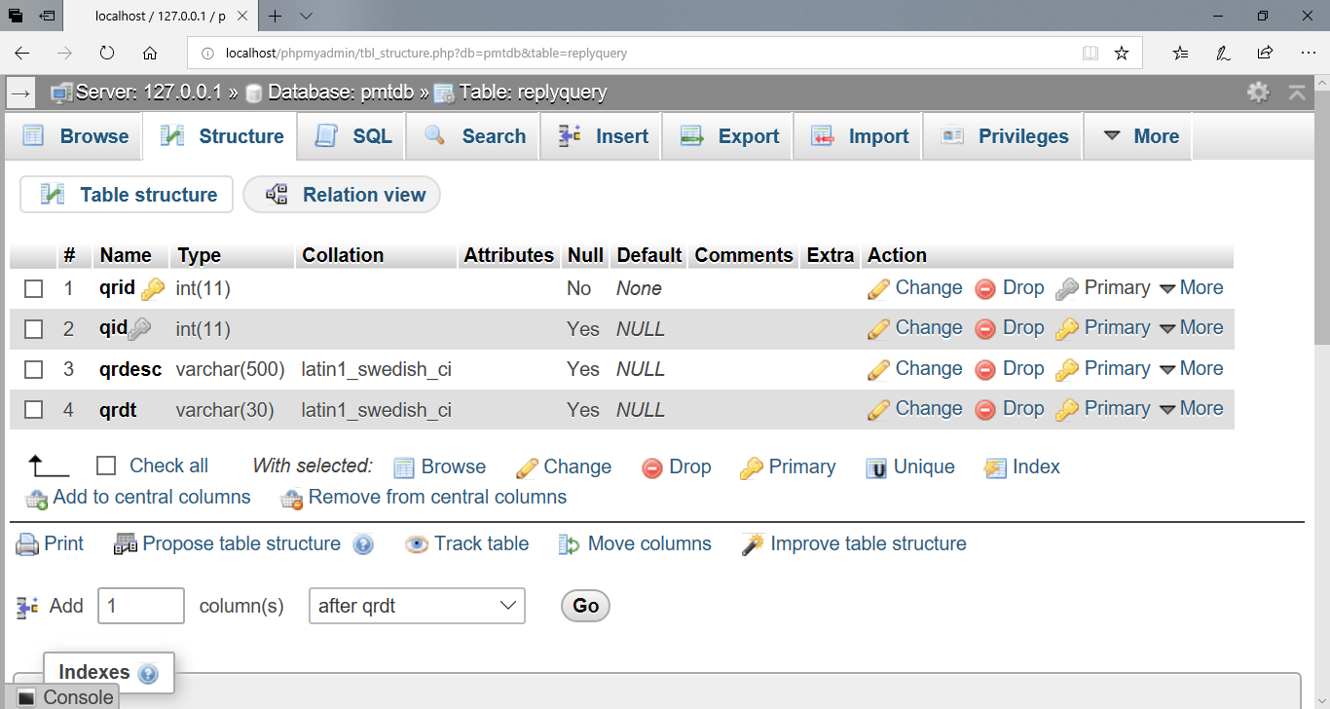

**Fig 3.8.8 Table for Reply of Query**

**ProjectReport Table:**

Following table is the table for Report of Project in Project Management Tool. This table contains a primary key “reportid” that is Project Reporting id by which ProjectReport can identify for all their activities related to project development. There are four columns other than the primary key column that are “reportdesc” ”that can manage the description of ProjectReport and “reportdt” that can manage the sending date of the ProjectReport.

The “reportid” column can’t be null because this is primary key column of ProjectReport, It means ProjectReport id can’t be null and duplicate. There is two more column that are “reportto” and “reportby” that make as foreign key column in which “reportto” references to the Employee table primary column. And “reportby” also references to the Employee table primary key. Since “reportid” column of ProjectReport table made as foreign key column the value of this column can’t be null but can be duplicate.

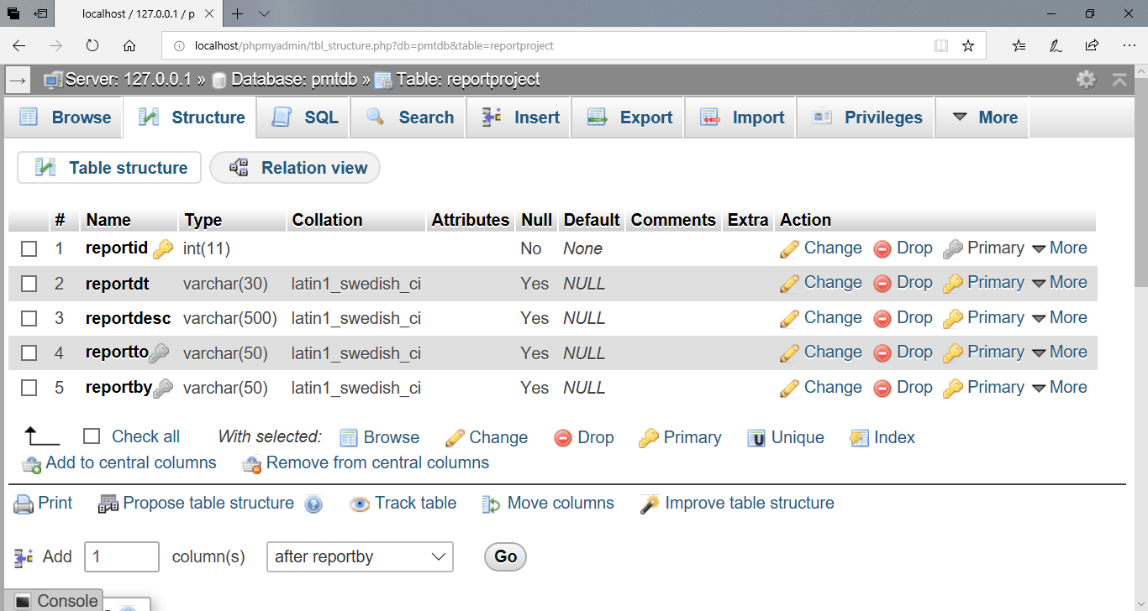

**Fig 3.8.9 Table for Reply of Project Report**

**ProjectReportReply Table:**

Following table is the table for Reply of ProjectReport in Project Management Tool. This table contains a primary key “replyid” that is ProjectReportReply id by which ProjectReportReply can identify for all their activities related to project development. There are five columns other than the primary key column that are “replydesc” ”that can manage the description of ProjectReportReply and “repreplydt” that can manage the sending date of the ProjectReportReply on which manager reply of the ProjectReport.

The “replyid” column can’t be null because this is primary key column means ProjectReportReply id can’t be null and duplicate. There is one more column that are “reportid” that make as foreign key column in which “reportid” references to the ProjectReport table primary column. Since “reportid” column of ProjectReportReply table made as foreign key column the value of this column can’t be null but can be duplicate.

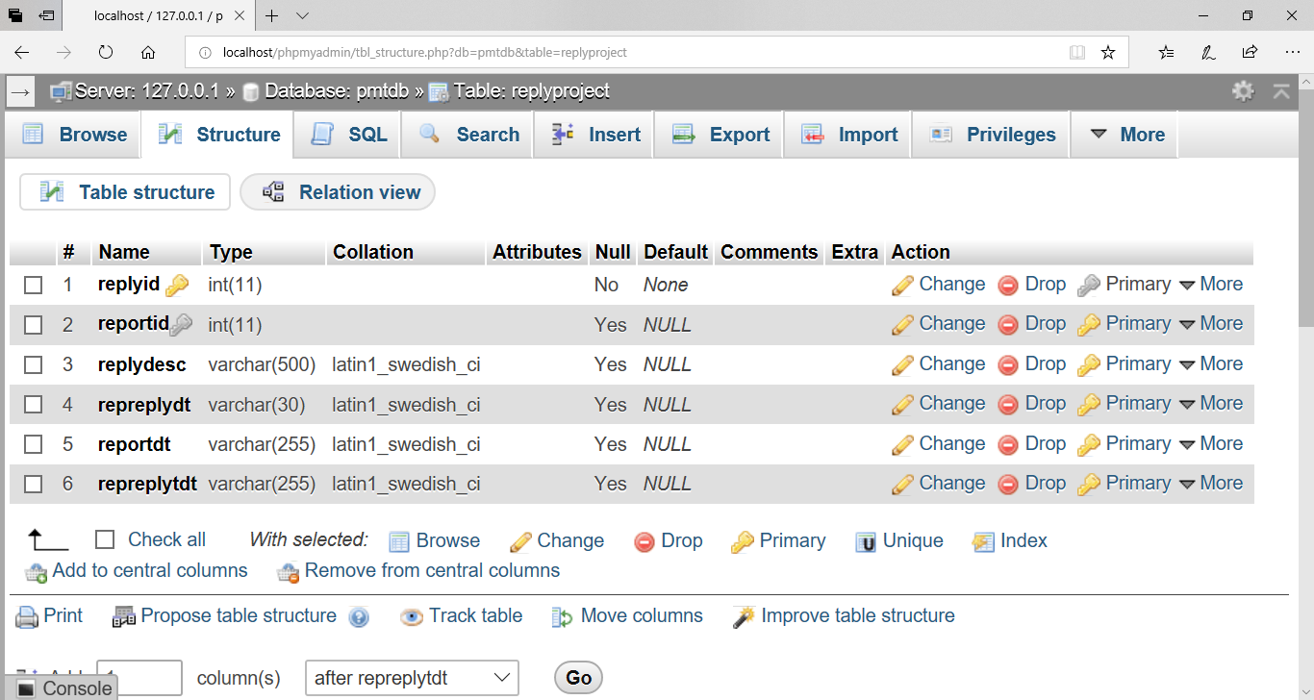

**Fig 3.8.10 Table for Report of Project**

**3.9 Few Logics**

**Logic for Template of Hibernate Connection:**

package tamplate;

import org.hibernate.Query;

import org.hibernate.Session;

import org.hibernate.SessionFactory;

import org.hibernate.Transaction;

import org.hibernate.cfg.Configuration;

public class HiberConnection

{

public static Configuration cfg;

public static SessionFactory sf;

public static Session s;

public static Transaction tx;

public static void setConnection()

{

cfg=new Configuration();

cfg.configure("cfsi.cfg.xml");

sf=cfg.buildSessionFactory();

s=sf.openSession();

}

public static void insertData(Object ob)

{

tx=s.beginTransaction();

s.save(ob);

tx.commit();

}

public static Query selectData(String qr)

{

Query q=s.createQuery(qr);

return q;

}

public static Object findData(Class c,int fid)

{

Object o=s.load(c, fid);

return o;

}

public static Object findDataS(Class c,String fid)

{

Object os=s.load(c, fid);

return os;

}

public static void updateData(Object ob)

{

tx=s.beginTransaction();

s.update(ob);

tx.commit();

}

public static void deleteData(Object ob)

{

tx=s.beginTransaction();

s.delete(ob);

tx.commit();

}

public static void closeConnection()

{

s.close();

}

}

Set connection is one of the first functions used in my project which is used to configure the connection to a particular module at the particular time limit. The set connection function is mainly used for establishing connection between the database and our application. Without this any one can’t do any database operation because every operation related to the database are done only and only after the database connection.

In the hibernate template the Configuration is a class that is used for database configuration and Session factory is factory of Session and Session is an interface that is used to save date and for transaction into the database.

The object that is saved in session is called persistence object and when the session destroyed the saved object of session is called as detached object. This object has no connection from the database.

Database theory encapsulates a broad range of topics related to the study about the database in the development system and research of the theoretical consents that is really very help full in my consents of the DB related arguments and consents and properties also related to the database and database management system consents.

Theoretical aspects of the data management includes many things in database, among other areas of the coding in the database, the foundations of queries languages are available with the great qualities for the databases, computational complexity and expressive power of queries in the programs, Definite are available here, database design theory is here too, dependency theory also, foundations of concurrency controls is also and database recovery is also available in the database consents, deductive databases available, temporal and spatial databases qualities is also available, in real time databases, managing uncertain data and probabilistic databases also there, and Web data of the database related things.

Most research work has traditionally been based on the relational model to be searched a lot about the database daily to daily the working on it concepts’ are making for developments of the real time of the project, since this model is usually considered that the simplest and most foundational model of interest in the it world. Corresponding results for the other data models is very goodly available, such as object-oriented or semi-structured models in the c and c++, or even in java also, more recently newly related things are available in the database, graph data models and XML that is welcome file of any of the project, are often derivable of the database from those for the relational model.

Create query is used to create the data inside the database such as creating the tables.

Insert query is used to insert the data in to the database in the particular database.

Select query is the query which is used to select the defined data from the database and also very effective things that is very useful now days to see the huge amount of the data by fetching from the database.

Update query also used in my template where all the queries are defined to be processing as per the requirements of the users.

Find data a query for finding the data is also very effective to search the particular data from the database to be uniquely identified by the users.

Find methods works in two differs faces in two different types like in the first face that is used to find the integer values only and that should be primary key of that particular table and In second face it also search the string form of the data also by the user requirements.

Delete query is also very important to delete the particular record from the databases per the user requirement. This template makes the database work very easy if required then we can use the required function this prevents the time of user and also prevents from the writing database code again and again thus the coding is very clear to understand.

Database coding is saperate from other page so if any changes required then needed changes only in hibernate template file. If required to use insert delete operation in any page then developer can call these function of hibernate template.

By the help of this template developer work is very easy normal coding and database coding are saperate from each other thus there is no possibility to occur collision in coding.

**Code of Header of the home page:**

The following code is for header of the navigation bar and header of home page by which internal pages open for the further working. The header contains email, mobile number and some social media link.

In navigation bar contains the “About Us” menu that contains the content about the organization, and in “contact us” menu contains the contact form for user, in “register” menu contains the registration form for the client registration and finally a menu for the “login” that show a popup login window that is common for all types users login like admin, manager, developer and client.

<header id="header" id="home">

<div class="header-top">

<div class="container">

<div class="row">

<div class="col-lg-6 col-sm-6 col-4 header-top-left no-padding">

<ul>

<li><a href="#"><i class="fa fa-facebook"></i></a></li>

<li><a href="#"><i class="fa fa-twitter"></i></a></li>

<li><a href="#"><i class="fa fa-dribbble"></i></a></li>

</ul>

</div>

<div class="col-lg-6 col-sm-6 col-8 header-top-right no-padding">

<a href="tel:+880 012 3654 896">+8827960736</a> <a href="">artideosar@gmail.com</a>

</div>

</div>

</div>

</div>

<!-- Header Content -->

<div class="container main-menu">

<div class="row align-items-center justify-content-between d-flex ">

<div id="logo" style="padding-top: 10px;" style="float:left;">

<a href="index.spring"><img src="img/logo1.png" alt="" height="35px" width="150px" /></a>

</div>

<nav id="nav-menu-container">

<ul class="nav-menu" style="float: right; margin-top: -30px;">

<li class="menu-active"><a href="index.spring"

style="hover {color: red;">Home</a></li>

<li><a href="about.spring">About Us</a></li>

<li><a href="contact.spring">Contact Us</a></li>

<li><a href="register.spring">Register</a></li>

<li><a class="open-button" onclick="openForm()"

style="color: white; opacity: 0.7; cursor: pointer;background-color: black;"><b>Login</b></a>

</ul>

</nav>

<!-- #nav-menu-container -->

</div>

</div>

</header>

<!-- #header -->

**Code of Login window:**

Following is the code for the login window of public page. By this window anyone can login. After login according to the user role it redirect to the corresponding dashboard. This login window come in popup when click on login button on navigation bar. For this popup window used some logics of scripts that are given inside the script tag. In this window have two options one to show password for the working of this feature uses javascript code that is written in below and another feature if for forget password if user forget their password then this feature will be helpful.

<div class="form-popup" id="myForm" style="height: 300px;">

<div style="margin-top: 10px; width: 100%;">

<span class="lclose" onclick="closeForm()"style="margin-right: 20px; cursor: pointer;">&times;</span>

<h2 style="font-size: 27px; font-weight: 400; color: white; margin-top: 1px; margin-left: 20px; float: left;">Login</h2>

</div>

<div style="margin-top: 60px; width: 100%; padding: 20px;">

<form action="loginlogic.spring" method="post" id="search_form">

<input type="text" name="txtuser" placeholder="Enter Username "

onfocus="hideError()" class=" linput" style="padding: 5px;"

required /><br />

<br /> <input type="password" name="txtpass” id="pass" placeholder="Enter Password "onfocus="hideError()" class=" linput" style="padding: 5px;" required />

<div style="text-align: left; margin-top: 10px;">

<h6 style="color: white;"><input type="checkbox" onclick="myFunction()"> <i>Show Password</i><h6>

</div>

<div style="text-align: center; margin-top: 10px; float: right;">

<a href="forgetpass.spring" style="color: orange; font-size: 12px; text-decoration: none;">ForgetPassword?</a>

</div>

<div style="display: none; margin-top: 35px; margin-left: 15px; position: fixed;" id="error">

<h6 style="color: red;">${msg}</h6>

</div>

<div style="text-align: center; margin-top: 55px; width: 50%; margin-left: 70px;">

<button onclick="form_submit()" name='login' value='Login' style="padding-top: 9px; padding-bottom: 6px;" value="Login"class="lsubmit">Login</button>

</div>

</form>

</div>

</div>

<script type="text/javascript">

function myFunction() {

var x = document.getElementById("pass");

if (x.type === "password")

{

x.type = "text";

}

else

{

x.type = "password";

}

}

function hideError() {

document.getElementById("error").style.display = "none";

}

function openForm() {

document.getElementById("myForm").style.display = "block";

}

function closeForm() {

document.getElementById("myForm").style.display = "none";

}

function form_submit() {

document.getElementById("search_form").submit();

}

</script>

**Logic for Login particular user:**

Following code is of the login of any type of user. For the login of any user following logic required in this project. If any user login to the login window then request for the loginlogic url. This url map with the controller url by the request dispatcher then the user identified according to the role the user is admin or client or manager or developer. After the identification of user corresponding page will be open for further working.

@RequestMapping("/loginlogic")

public ModelAndView logincode(HttpServletRequest req,HttpServletResponse res)

{

HttpSession sess = req.getSession();

String uid = req.getParameter("txtuser");

String pass = req.getParameter("txtpass");

HiberTemplate.setConfiguration();

String a = "from Admin obj where obj.aid=:u and obj.apass=:p";

Query qa = HiberTemplate.getData(a);

qa.setString("u", uid);

qa.setString("p",pass);

List lsta = qa.list();

String c = "from Client obj where obj.cid=:u and obj.cpass=:p";

Query qc = HiberTemplate.getData(c);

qc.setString("u", uid);

qc.setString("p",pass);

List lstc = qc.list();

String h = "from Employee obj where obj.eid=:u and obj.epass=:p and obj.designation=:d";

Query qh = HiberTemplate.getData(h);

qh.setString("u", uid);

qh.setString("p",pass);

qh.setString("d","Manager");

List lsth = qh.list();

String d = "from Employee obj where obj.eid=:u and epass=:p and obj.designation=:d";

Query qd= HiberTemplate.getData(d);

qd.setString("u", uid);

qd.setString("p",pass);

qd.setString("d","Developer");

List lstd = qd.list();

if(lsta.size()>0)

{

sess.setAttribute("suid",uid);

return new ModelAndView("redirect:admindash.spring");

}

else if(lstc.size()>0)

{

sess.setAttribute("suid",uid);

return new ModelAndView("redirect:clientdash.spring");

}

else if(lsth.size()>0)

{

sess.setAttribute("suid",uid);

return new ModelAndView("redirect:managerdash.spring");

}

else if(lstd.size()>0)

{

sess.setAttribute("suid",uid);

return new ModelAndView("redirect:developerdash.spring");

}

sess.setAttribute("lo", "wrong");

return new ModelAndView("redirect:home.spring");

}

@RequestMapping("/home")

public ModelAndView homepagi()

{

return new ModelAndView("index","msg","Invalid username and password");

}

**Logic for approve user**

Following code is for the approval, the approval is very important for the manager, developer and client to do their further work. The approval(permission) given by the admin to any type of user.

/* APPROVE */

@RequestMapping("/aempapprove")

public ModelAndView showeAp(HttpServletRequest req, HttpServletResponse res)

{

HiberTemplate.setConfiguration();

Employee s1=(Employee)HiberTemplate.findOperationString(Employee.class,req.getParameter("eid"));

HttpSession sess = req.getSession();

s1.setEstatus(1);

sess.setAttribute("ea","correct");

HiberTemplate.updateOperation(s1);

HiberTemplate.closeConn();

return new ModelAndView("redirect:/succempedit.spring");

}

**Logic for block user**

The following code is to block the users after blocking the user, can’t perform their activities, means if any requirement come like that to ban user to perform their activities this option be very helpful.

/* BLOCK */

@RequestMapping("/aempblock")

public ModelAndView showeblock(HttpServletRequest req, HttpServletResponse res)

{

HiberTemplate.setConfiguration();

Employee s1=(Employee)HiberTemplate.findOperationString(Employee.class,req.getParameter("eid"));

HttpSession sess = req.getSession();

s1.setEstatus(2);

sess.setAttribute("ea","correct");

HiberTemplate.updateOperation(s1);

HiberTemplate.closeConn();

return new ModelAndView("redirect:/succempedit.spring");

}

**Logic for edit profile**

The following code is responsible for editing the profile of user. If any user wants to change their profile then this will be possible only by the help of this code. But any user can’t change their own all data of profile; user can change only some data.

/***Edit Profile***/

@RequestMapping("/aeditprofile")

public ModelAndView show4(HttpServletRequest req, HttpServletResponse res)

{

HiberTemplate.setConfiguration();

Admin s2=(Admin)HiberTemplate.findOperationString(Admin.class,req.getParameter("aid"));

HttpSession sess = req.getSession();

sess.setAttribute("adminpf","correct");

s2.setAid(req.getParameter("aid"));

s2.setApass(req.getParameter("apass"));

s2.setAname(req.getParameter("aname"));

s2.setAmbno(req.getParameter("ambno"));

HiberTemplate.updateOperation(s2);

HiberTemplate.closeConn();

return new ModelAndView("redirect:/succapf.spring");

}

@RequestMapping("/succapf")

public ModelAndView show5(HttpServletRequest req, HttpServletResponse res)

{

return new ModelAndView("admindash");

}

**Logic for edit Employee**

Following coding is of the edit the employees by the admin. Only admin can edit the employees no one other. When admin start editing the employee then following code will run.

@RequestMapping("/aempedit")

public ModelAndView showe(HttpServletRequest req, HttpServletResponse res)

{

HiberTemplate.setConfiguration();

Employee s1=(Employee)HiberTemplate.findOperationString(Employee.class,req.getParameter("eid"));

HttpSession sess = req.getSession();

s1.setEname(req.getParameter("ename"));

s1.setEid(req.getParameter("eid"));

s1.setEpass(req.getParameter("epass"));

s1.setEmbno(req.getParameter("embno"));

s1.setEregdt(req.getParameter("eregdt"));

s1.setDesignation(req.getParameter("designation"));

s1.setTechnology(req.getParameter("technology"));

s1.setEgender(req.getParameter("egender"));

s1.setEstatus(Integer.parseInt(req.getParameter("estatus")));

sess.setAttribute("ea","correct");

HiberTemplate.updateOperation(s1);

HiberTemplate.closeConn();

return new ModelAndView("redirect:/succempedit.spring");

}

**Logic for assign project**

The following code is for assigning the project to manager and same logic is used for the module assignment for the developer by the manager. If any project assigned to a manager then the status of that manager automatically will be 3 and this manager can’t assign for the other project.

@RequestMapping("/aprojectedit")

public ModelAndView showcp(HttpServletRequest req, HttpServletResponse res)

{

HiberTemplate.setConfiguration();

ProjectMaster s1=(ProjectMaster)HiberTemplate.findOperation(ProjectMaster.class,req.getParameter("pid"));

HttpSession sess = req.getSession();

s1.setPtitle(req.getParameter("ptitle"));

s1.setPdeldt(req.getParameter("pdeldt"));

s1.setPdesc(req.getParameter("pdesc"));

s1.setPostdt(req.getParameter("postdt"));

s1.setPassigndt(req.getParameter("passigndt"));

s1.setPsubdt(req.getParameter("psubdt"));

s1.setPcost(Integer.parseInt(req.getParameter("pcost")));

s1.setPstatus(Integer.parseInt(req.getParameter("pstatus")));

s1.setPwork(req.getParameter("pwork"));

s1.setEid(req.getParameter("eidm"));

//s1.setCid(req.getParameter("cid"));

if(req.getParameter("eidm")!=null)

{

Employee e1=(Employee)HiberTemplate.findOperationString(Employee.class,req.getParameter("eidm"));

e1.setEstatus(3); //assigned

Employee e2=(Employee)HiberTemplate.findOperationString(Employee.class,req.getParameter("oldeidm"));

e2.setEstatus(1);

HiberTemplate.updateOperation(e1);

HiberTemplate.updateOperation(e2);

}

sess.setAttribute("pa","correct");

HiberTemplate.updateOperation(s1);

HiberTemplate.closeConn();

return new ModelAndView("redirect:/succempedit.spring");

}

**Logic for the admin dashboard data**

Following logic is of the data that display on the admin dashboard like- new projects, completed projects, number of clients, number of developers, number of manager and number of technology expert for the development. To show these data count sql query used that return the count of all rows that satisfies the particular given condition.

<%

HiberTemplate.setConfiguration();

Query pr =HiberTemplate.getData("SELECT COUNT(*) FROM ProjectMaster u where u.passigndt=:as");

pr.setString("as","");

Long npr=(Long)pr.uniqueResult();

Query pr1 =HiberTemplate.getData("SELECT COUNT(*) FROM ProjectMaster m1 where m1.pwork=:pw");

pr1.setString("pw","Done");

Long cpr=(Long)pr1.uniqueResult();

Query d =HiberTemplate.getData("SELECT COUNT(*) FROM Employee m2 where m2.designation=:ds");

d.setString("ds","Developer");

Long tdev=(Long)d.uniqueResult();

Query man =HiberTemplate.getData("SELECT COUNT(*) FROM Employee m3 where m3.designation=:ms");

man.setString("ms","Manager");

Long tman=(Long)man.uniqueResult();

Query nc =HiberTemplate.getData("SELECT COUNT(*) FROM Client m3 where m3.caprstatus=:ms");

nc.setString("ms","0");

Long tnc=(Long)nc.uniqueResult();

HiberTemplate.closeConn();

%>

<div class="panel panel-container">

<div class="row">

<div class="col-xs-6 col-md-3 col-lg-2 no-padding">

<div class="panel panel-teal panel-widget border-right">

<div class="row no-padding">

<em class="fa fa-xl fa-tasks color-blue"></em>

<div class="large"><%=npr%></div>

<div class="text-muted">New Projects</div>

</div>

</div>

</div>

<div class="col-xs-6 col-md-3 col-lg-2 no-padding">

<div class="panel panel-blue panel-widget border-right">

<div class="row no-padding">

<em class="fa fa-xl fa-files-o color-teal"></em>

<div class="large"><%=cpr%></div>

<div class="text-muted">Complete Projects</div>

</div>

</div>

</div>

<div class="col-xs-6 col-md-3 col-lg-3 no-padding">

<div class="panel panel-blue panel-widget border-right">

<div class="row no-padding">

<em class="fa fa-xl fa-users color-blue"></em>

<div class="large"><%=tnc%></div>

<div class="text-muted">New Clients</div>

</div>

</div>

</div>

<div class="col-xs-6 col-md-3 col-lg-3 no-padding">

<div class="panel panel-orange panel-widget border-right">

<div class="row no-padding">

<em class="fa fa-xl fa-users color-teal"></em>

<div class="large"><%=tdev%></div>

<div class="text-muted">Developers</div>

</div>

</div>

</div>

<div class="col-xs-6 col-md-3 col-lg-2 no-padding">

<div class="panel panel-red panel-widget ">

<div class="row no-padding">

<em class="fa fa-xl fa-user color-red"></em>

<div class="large"><%=tman%></div>

<div class="text-muted">Managers</div>

</div>

</div>

</div>

</div>

**Logic for table search**

Following is the logic of the table search in javascript, when user select the option from the dropdown that reference the table column for the search, when user starts to enter any data the matched row of entered data will show and all data doesn’t display.

<script>

function myFunction() {

document.getElementById("myInput").style.visibility="visible";

document.getElementById("s").style.visibility="visible";

var p=document.getElementById("searchby");

var a = p.options[p.selectedIndex].value;

document.getElementById("myInput").placeholder=a;

}

function mySearch() {

var n=(document.getElementById("searchby").selectedIndex)-1;

var a=0;

var input, filter, table, tr, td, i, txtValue;

input = document.getElementById("myInput");

filter = input.value.toUpperCase();

table = document.getElementById("emptable");

tr = table.getElementsByTagName("tr");

for (i = 0; i < tr.length; i++) {

for (j = 0; j < 10; j++)

{

if(n>=2)

{

if(n+1==j)

td = tr[i].getElementsByTagName("td")[j];

}

else

{

if(n==j)

td = tr[i].getElementsByTagName("td")[j];

}

}

if (td)

{

txtValue = td.textContent || td.innerText;

if (txtValue.toUpperCase().indexOf(filter) > -1)

{

tr[i].style.display = "";

}

else

{

tr[i].style.display = "none";

}

}

}

}

</script>

**Logic for show the selected option in search box**

Following code is used for when the option selected from the dropdown list the selected option will show into the searchbox. For this used following javascript code.

<select name="eidm" style="border: 1px solid #CCCCCC;height:24px;"width:100px class="mdropdown" disabled>

<option value="<%=em.getEid()%>"><%=em.getEid()%></option>

<%

Query qm=HiberTemplate.getData("from Employee c where c.designation=:d");

qm.setString("d","Manager");

List lstm=qm.list();

Iterator itm=lstm.iterator();

while(itm.hasNext())

{

int checkm=0;

Employee emi=(Employee)itm.next();

Query qmw=HiberTemplate.getData("from ProjectMaster c where c.eid=:dw");

qmw.setString("dw",emi.getEid());

List lstmw=qmw.list();

Iterator itmw=lstmw.iterator();

while(itmw.hasNext())

{

ProjectMaster emiw=(ProjectMaster)itmw.next();

if(!emiw.getPwork().equals(new String("100"))) //if any project is running

{

checkm=1;

}

}

if(checkm==0)

{

%>

<option><%=emi.getEid()%></option>

<%

}

}

%>

</select>

**Logic for read-only field make as writable when click on button**

Following code is for when a table show in front of the user and all field of table are read only and needed writable field to editing something then this code play important role.

<script>

function funp() {

var x = document.getElementsByClassName("p");

for (var i = 0; i < x.length; i++)

{

x[i].removeAttribute("readonly");

x[i].style.backgroundColor="#F8F8F8";

document.getElementById("tds").style.visibility="visible";

}

}

</script>

**Logic for query and reply of query of client**

Following code manages the client’s queries and reply of the clients query that is written in java using hibernate. When client have any query then post the query that will be view by the corresponding manager that manage the project of that client, for this process addquery code execute and when the manager reply the query of the client then reply query code will be executed.

/*** Insert Query ***/

@RequestMapping("/addquery")

public ModelAndView qery(HttpServletRequest req, HttpServletResponse res)

{

HiberTemplate.setConfiguration();

QueryC sc=new QueryC();

HttpSession sess = req.getSession();

sess.setAttribute("pa","correct");

DateFormat dateFormat = new SimpleDateFormat("yyyy/MM/dd HH:mm:ss");

Date date = new Date();

String dt=dateFormat.format(date);

sc.setQtitle(req.getParameter("qtitle"));

sc.setCid(req.getParameter("cid"));

sc.setQdesc(req.getParameter("qdesc"));

sc.setQdt(dt);

HiberTemplate.InsertOperation(sc);

HiberTemplate.closeConn();

return new ModelAndView("redirect:/clienthome.spring");

}

/*** Reply client query ***/

@RequestMapping("/replyquery")

public ModelAndView repqery(HttpServletRequest req, HttpServletResponse res)

{

HiberTemplate.setConfiguration();

ReplyQuery sc=new ReplyQuery();

HttpSession sess = req.getSession();

sess.setAttribute("qa","correct");

DateFormat dateFormat = new SimpleDateFormat("yyyy/MM/dd HH:mm:ss");

Date date = new Date();

String dt=dateFormat.format(date);

sc.setQrdesc(req.getParameter("qrdesc"));

sc.setQid(Integer.parseInt(req.getParameter("qid")));

sc.setQrdt(dt);

HiberTemplate.InsertOperation(sc);

HiberTemplate.closeConn();

return new ModelAndView("redirect:/managerhome.spring");

}

**CSS for Table of Employee**

Following code is used for employee table on which employee list show and this contains the options of edit, delete, approve and block option to manage employee. For this used button tag.

.emp

{

border-collapse: collapse;

width: 100%;

font-size:12px;

}

.emp tr th

{

padding: 5px;

text-align: center;

border-top: 1px solid #bbb;

border-bottom: 2px solid #bbb;

}

.emp tr td

{

padding: 2px;

text-align: center;

border-bottom: 1px solid #ddd;

}

.emp tr td a

{

text-decoration:none;

color:black;

}

.emp tr td textarea

{

border:none;

outline:none;

resize: none;

width:90px;

background-color:white;

text-align: center;

}

.emp tr td input,button

{

border:none;

width:50px;

margin-top:-10px;

background-color:white;

text-align: center;

}

**CSS for employee registration form**

Following css is for the registration form for the client and employees. In the registration form input tag, select tag and button tag used for these tag css defined in following css code.

.form-style-9

{

max-width: 600px;

background: #FFFFFF;

padding: 30px;

padding-top:10px;

margin: -60px auto;

box-shadow: 1px 1px 20px rgba(0, 0, 0, 0.35);

border-radius: 0px;

}

.form-head

{

background-color:black;

padding:10px;

height:55px;

margin-top:-10px;

margin-left:-30px;

margin-right:-30px;

margin-bottom:30px;

}

.form-style-9 ul

{

margin:0;

list-style:none;

}

.form-style-9 ul li

{

display: block;

margin-bottom: 20px;

min-height: 35px;

}

.form-style-9 ul li .field-style

{

box-sizing: border-box;

-webkit-box-sizing: border-box;

-moz-box-sizing: border-box;

padding: 8px;

outline: none;

font-family: "Roboto", "Arial", "Helvetica Neue", sans-serif;

font-weight: 400;

font-size: 14px;

-webkit-transition: all 0.30s ease-in-out;

-moz-transition: all 0.30s ease-in-out;

-ms-transition: all 0.30s ease-in-out;

-o-transition: all 0.30s ease-in-out;

}

.form-style-9 ul li .field-style:focus

{

box-shadow: 0 0 5px #B0CFE0;

border:1px solid #B0CFE0;

border-bottom: 2px solid #F08708;

}

.form-style-9 ul li .field-split

{

width: 47%;

}

.form-style-9 ul li .field-full

{

width: 100%;

}

.form-style-9 ul li input.align-left

{

float:left;

}

.form-style-9 ul li input.align-right

{

float:right;

}

.input-group

{

position: relative;

margin-bottom: 30px;

font-size: 18px;

}

.form-style-9 ul li textarea{

width:100%;

height: 50px;

resize:none;

overflow: hidden;

}

.form-style-9 ul li input[type="button"],

.form-style-9 ul li input[type="submit"],.form-style-9 ul li input[type="reset"]

{

-moz-box-shadow: inset 0px 1px 0px 0px #3985B1;

-webkit-box-shadow: inset 0px 1px 0px 0px #3985B1;

box-shadow: inset 0px 1px 0px 0px #3985B1;

background-color: #000000;

border: 1px solid #17445E;

display: inline-block;

cursor: pointer;

color: #FFFFFF;

padding: 5px 17px 5px 17px;

text-decoration: none;

font: 12px Arial, Helvetica, sans-serif;

position:center;

border-radius:50px;

}

.form-style-9 ul li input[type="button"]:hover,

.form-style-9 ul li input[type="submit"]:hover ,

.form-style-9 ul li input[type="reset"]:hover

{

background: linear-gradient(to bottom, #2D77A2 5%, #F38401 100%);

background-color: #F38401;

}

**Chapter: 4**

**Testing**

**Testing**

Testing is a software tool. No system design is ever perfect. Testing is done in two phases. Software testing will be large implementation of project testing. Second phase of testing is done after the completion of software. Without testing you can’t say any system have a feel of completeness. We also applied some sort of testing to our project.

If an application is implemented without being tested it may lead to an error full working and dissatisfaction on the side of the customer.

It will also prove the disastrous to the reputation of the organization or the person who developed the system and lead to loss in business. Keeping all these things under consideration, we left no stone unturned in testing our system. It was tested keeping in view the different possibilities on part of the user.

**Objectives of testing**

* The main purpose of testing and information system is to find the errors and correct them. In project testing of experience developer.
* To ensure that during the operation the system will perform as per specification.
* To make sure that the system meets user’s requirements.
* To verify that the control incorporated in the system function as intended.
* To see that when correct inputs are fed to the system, the outputs are correct.
* To make sure that during operations, incorrect inputs, processing and output will be detected.
* Testing includes how and in which manners the software is tested.
* The system is tested through the following techniques.
  + Dataflow testing
  + Interface testing
  + Unit testing
  + Condition testing
  + Loop testing
  + Functionality testing
  + Constraints testing
  + Integrated testing
  + System testing
  + Black-box testing
  + White-box testing

**White Box Testing**

In this technique, the close examination of the logical parts through the software is listed by cases that exercise species sets of conditions or loops.

All logical parts of the software checked once, which should be executed once may be getting executed more than once and error resulting by using wrong controls and loops. true and the false side are exercised, all loops and bounds within their operational bounds were exercised and internal data structure to ensure their validity were exercised once.

**Black Box Testing**

This method enables the software engineer to device sets of input techniques that fully exercise all functional requirements for a program.

**Alpha Testing**

Acceptance testing is also sometimes called alpha testing. Be spoke systems are developed for a single customer. The alpha testing proceeds until the system developer and the customer agree that the provided system is an acceptable implementation of the system requirements.

**Beta Testing**

On the other hand, when a system is to be marked as software is often conducted. At the time of beta testing, a system is delivered among a number of potential users who agree to use it. The problems reports to the developers by customer.

It provides the product for real use and detects errors that may not be anticipated by the system developers.

* **Unit Testing**

Each module is considered independently. It concentrate on each unit of software as implemented in the source code. It is white box testing.

* **Integrated Testing**

This testing aims at constructing the program structure while at the same constructing tests to uncover errors associated with interfacing the modules. Modules are integrated by using the top down approach.

* **Validation Testing**

This testing was performed to ensure that all the functional and performance requirements are met.

* **System Testing**

It is executing programs to check logical changes made in it with intention of finding errors. A system is tested for online response, volume of transaction, recovery from failure etc.

System testing is done to ensure that the system satisfies all the user requirements.

There are other six tests, which fall under special category. They are described below**:**

* **Peak load test:** It determines whether the system will handle the volume of activities that occur when the system is at the peak of its processing demand. For example, test the system by activating all terminals at the same time.
* **Storage Testing:** It determines the capacity of the system to store transaction data on a disk or in other files.
* **Performance Time Testing:** It determines the length of time system used by the system to process transaction data. Meany any transaction how much time take this will be analysed in performance time testing,

This test is conducted prior to implementation to determine how long it takes to get a response to an inquiry, make a backup copy of a file, or send a transmission and get a response.

* **Recovery Testing:** This testing determines the ability of user to recover data or re-start system after failure. For example, load backup copy of data and resume processing without data or integrity loss. In this testing tester test the application if any fault occurs then that fault can be recoverable or not. If recoverable then it will be good.
* **Procedure Testing:** It determines the clarity of documentation on operation and uses of system by having users do exactly what manuals request. Means by this documentation clarity will be checked.
* **Human Factors testing:** It determines how users will use the system when processing data or preparing reports. It determines the all errors when user prepares project report.

**Software testing is carried out in three steps:**

First of all do unit testing, where each module is tested to provide its correctness, validity and also determine any missing operations and to verify whether the objectives have been met. If any error then errors is noted down and corrected immediately. All the processes of testing that are given above are important for the software.

Then unit testing is the important and major part of the project. So errors are corrected easily in particular module and program clarity is increased. In my project entire system is divided into several modules and is developed individually. So unit testing is conducted to individual modules. By following the all types of testing, if any software tested then that software will be best performance in future and the life cycle of the software will be increased.

After the first step do Integration testing. Integration testing need not be the case, the software modules of that when run individually and showing perfect results, it will also show perfect results when run as a whole. It test the software run perfectly or not and performance of software good or not.

The every module is clipped under this major module and tested again and verified the results. This is done due to poor interfacing, which may results in data being lost across an interface. Every module tested in this testing one by one and analyse that they work accurately or not.

The final step involves validation and testing which determines which the software functions as the user expected. In this all the validation checked and also checks that output is according to the user expectation or not user can easily operate or not. Such that all the testing done before delivering the software to the user. If any error come then that error can be solved by developer. Here also some modifications were. In the completion of the project it is satisfied fully by the end user.

Thus we can say that the software testing is the important phase software development, it is done after the development of software but before delivering the software on the side of the client.

**Chapter: 5**

**Output Screen/Snapshots**

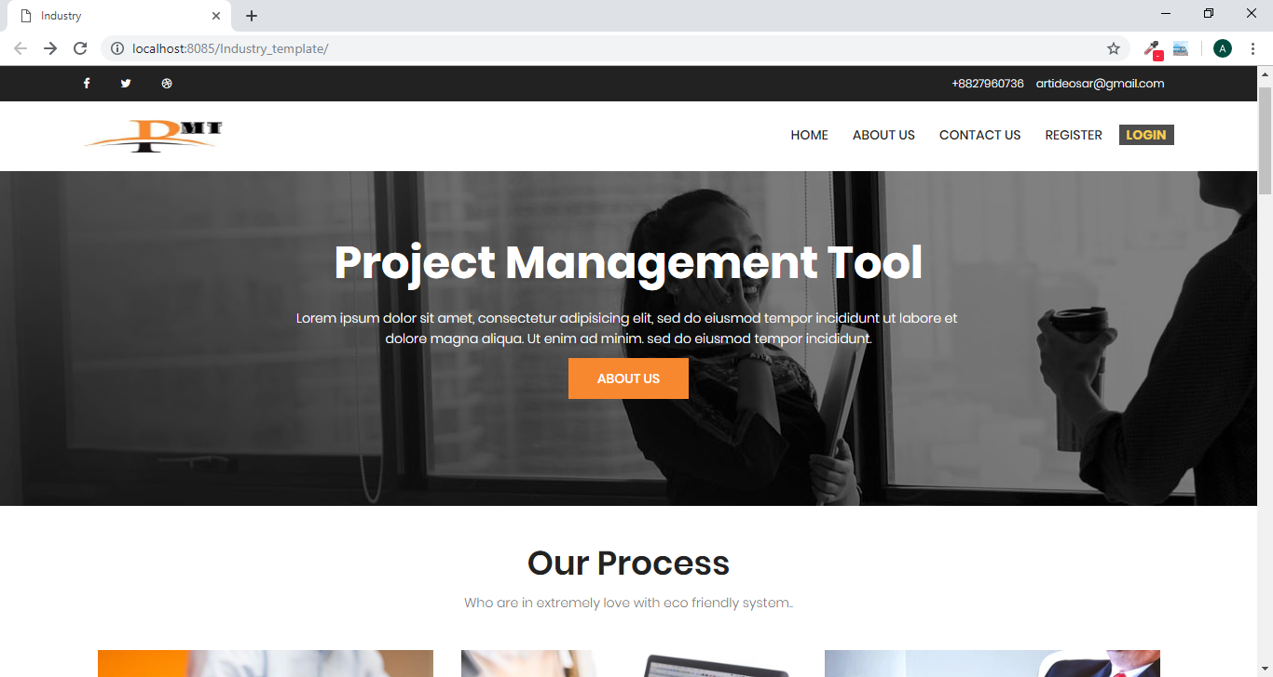

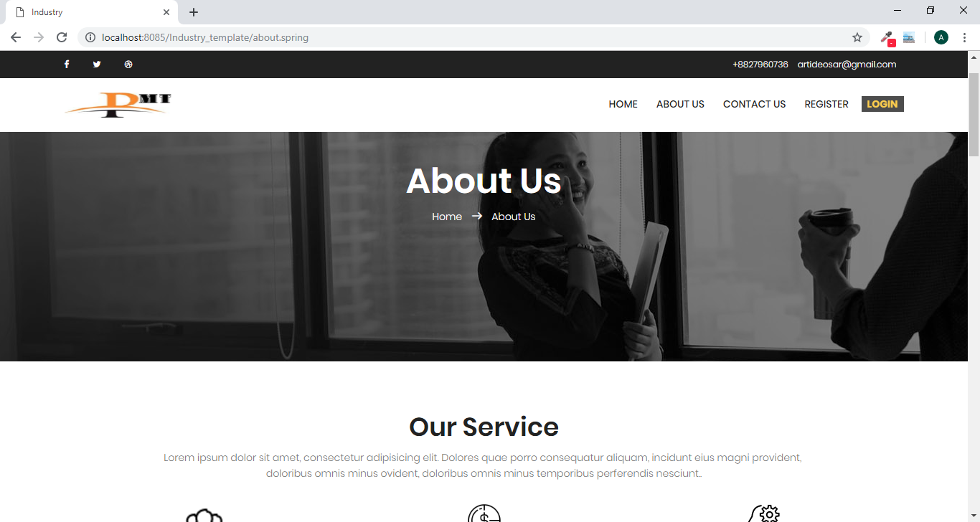

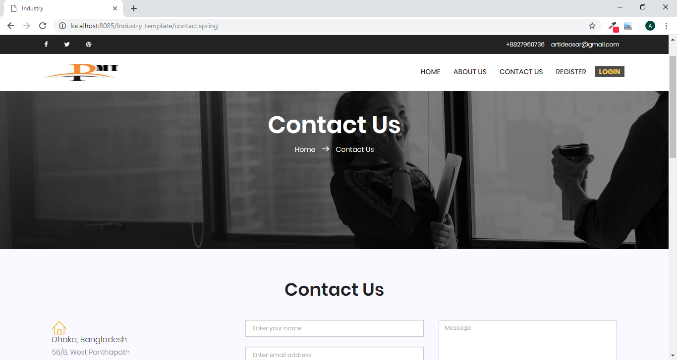

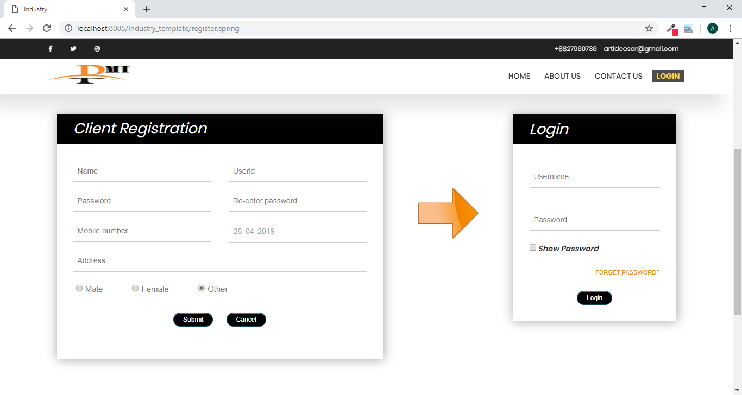

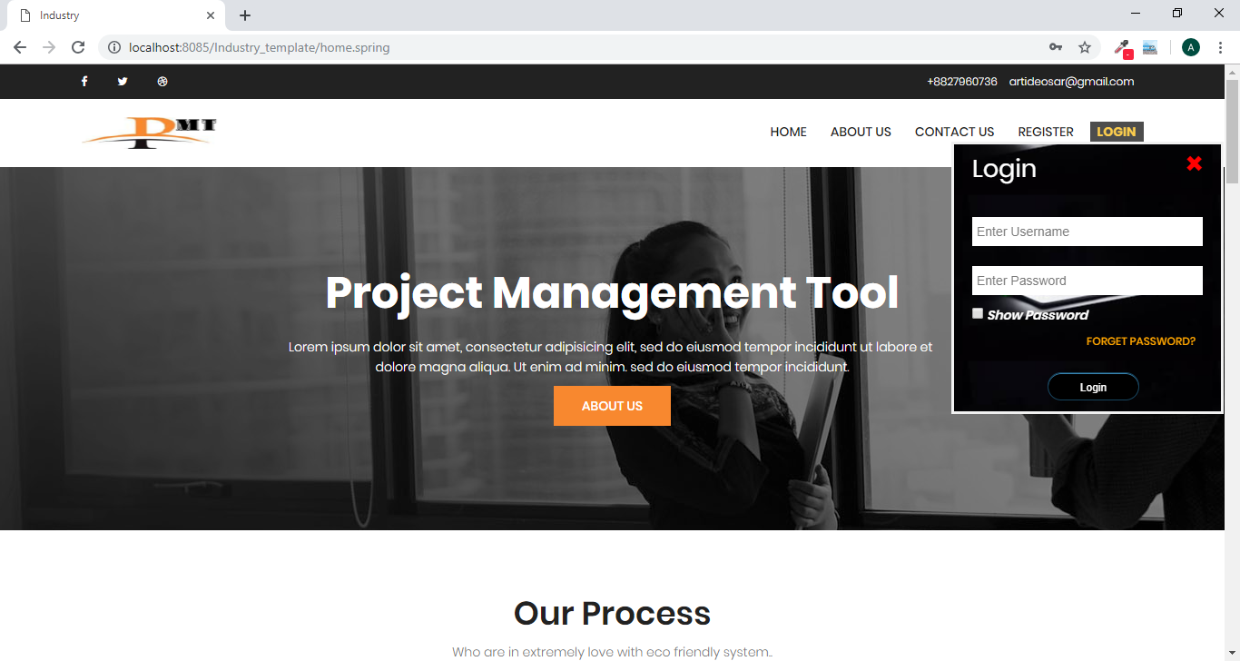

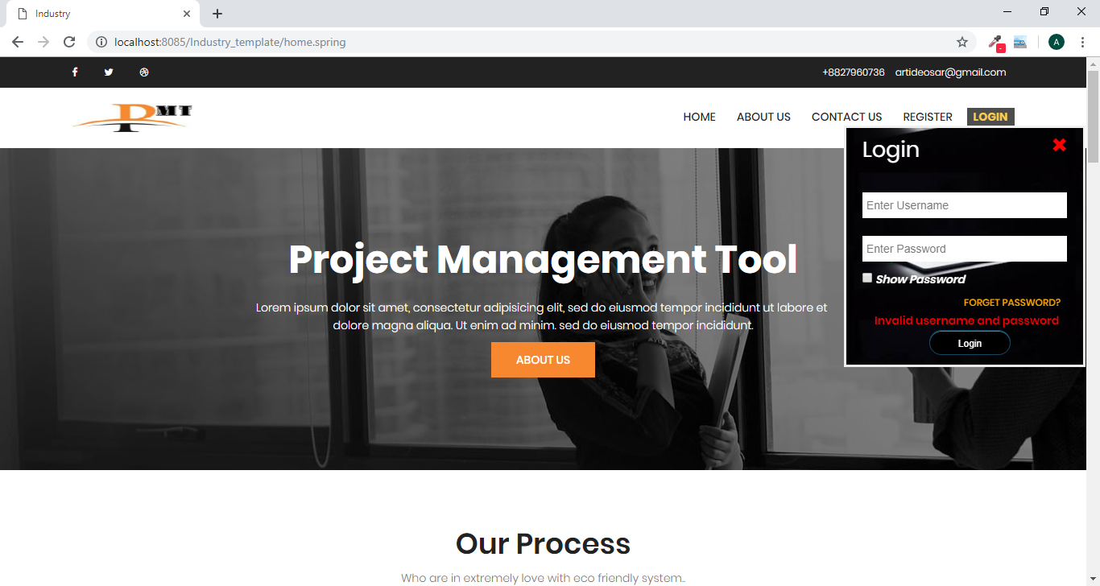

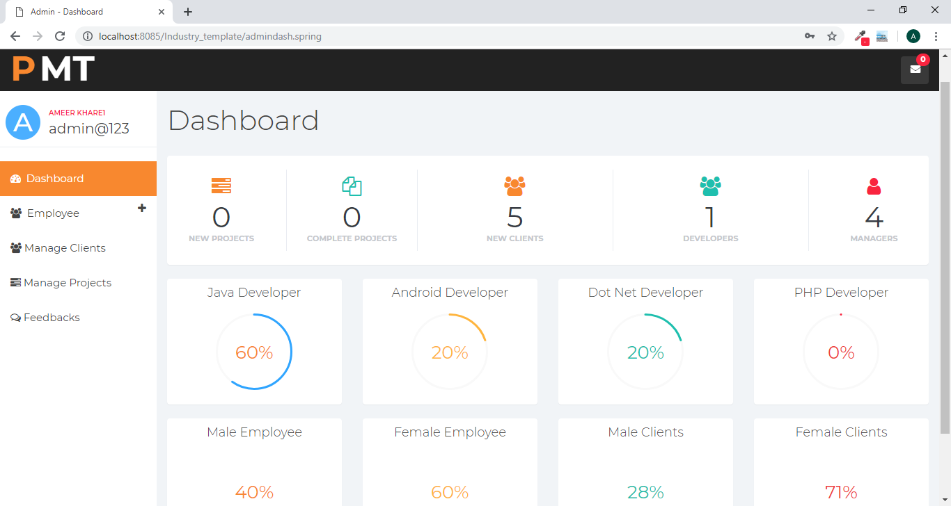

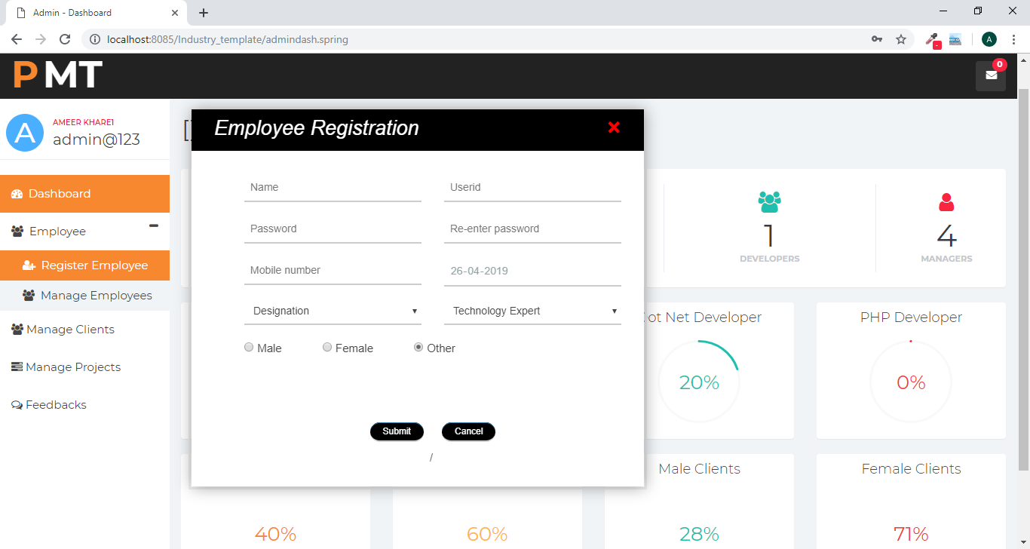

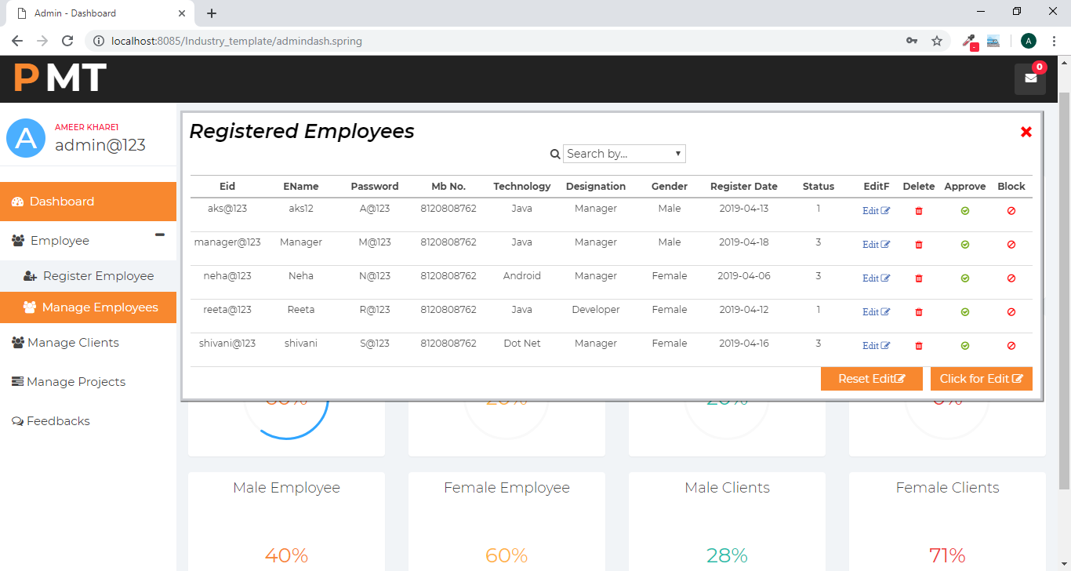

**Chapter: 6**

**Application and Scope**

**6.1 Application of the Project**

Project Management Tool is as a solution for the software development company for the devlopment process inside the organization. It makes the management of any project very easy and by using this max overhead of employees can be less because all the records relate to the development are stored by the project management tool, such that the overhead of saving the records for future can be removed.

Project Management Tool will be very helpful. Here we are trying to develop an application that provides a secure way to perform all activities related to project development within company.

In this project client direct interact to the company experts after accessing it. And admin and all employees can immediate starts their work very easily and frequently. The development of this new system contains the following activities, which try to automate the entire process keeping in the view of database integration approach.

Following are the advantages of using the Project Management Tool for the project development in any company:

* Now-a-days, almost all organizations are doing their works online by the application, like Storing records of daily activities and any advertisement related to project development. It saves clients, developer, manager and admin time to perform activities of project development. Because All Activities related to development perform direct in hardcopy or by mail is very complex as well as time consuming.
* If use this software for the project devlopment in any company then it makes the work of employees and admin and also client very easy.
* There is no overhead of the storing records for long time. Many times human memories not work accurate so the record can be loss thus this project will be very useful.
* Because of the lots of the benefits for the user by using this application, Peoples must use it. This application will be very effective to perform project management related tasks.
* Any company should use it always, because we will always try to add more features time to time according to the requirements. So the project or Application will be run able in future also like now.
* This project is also useful for the project clients because by using this project client can post their project anytime from anywhere after the permission of admin. This system maintains client’s personal address, contact and project details.
* User friendliness is provided in the application with various controls provided by system rich user interface.
* The system gives us high security for saving data because user authentication is high and there are no chances of data losing. This system makes the overall project management much easier and flexible.
* Various classes have been used for maintain the details of all the clients, developer and managers and work log. Authentication is provided for this application only registered users can access.
* Report generation features is provided using to generate different kind of reports. The system provides facilities to track the all activities of project development by the admin and project manager.
* System can also help to track all the employees work report and [project status daily to daily. System provides facility to approve and block the project, clients, project manager and developer.
* System also provides facility to upload project work status daily to daily by developers. The system provides facility to do all activities related to project management within a company.
* By this system all activities perform online like- project assignment, query of client, reporting of project so it will be easier to development team that can be able develop project by living anywhere in the world.

This system is providing feature to see project status by the client any time by login.

**6.2 Scope of the Project**

We need more time saving and more secure system as the number of applications is increasing day by day. So, Project Manager Tool is very useful today. It is very important to use this application to perform the tasks immediately related to the project development within a company. Now-a-days pollution is growing exponentially, so this project helps to prevent the environment by saving papers.

Because of the lots of the benefits for the user by using this application, Peoples must use it. This application will be very effective to perform project management related tasks. Any company should use it always, because we will always try to add more features time to time according to the requirements. So the project or Application will be run able in future also like now.

The updated versions of this application will be available in future made by us for making user’s requirements full fill. So we are sure about to update it according to the need of users. Now-a-days as the number of software companies are growing exponentially so that required an system that manage these activities in less effort, Such that Project Management Tool application System is helpful by reducing manual work as well providing extra features (like increasing efficiency and time saving).

The Project Management Tool has great scope in different any software development company. Here I am trying to develop an application that provide a way for communication and also provide facility to store work report and project status within company. In future I will try to enhance this application that provide a secure way for communication and also provide facility to store all records within organization in secure way. This will be possible by using encryption techniques.

The given terms and policies of our application may also be change according to the updating of our project in future. So it is very important to read the terms and policies at least one time for awareness of the client.

**Chapter: 7**

**Limitations and Future Enhancement**

**7.1 Limitations**

Project Management Tool manages the all activities related to project development only. With all features of Project Management Tool have some limitations; if these limitations are enhanced then the quality of project will be more.

The some limitations of this project are as following:

* In this project admin can manage only the developers and mangers in employees that can involve into the project development, but there is no feature to manage all the employees’ records and activities.
* The work of adding the employee into the company is of HR but because of the less number of modules admin add the employees into the company.
* If manager wants to see the project report they can’t see online, this is done offline.
* Developer can’t upload the daily module work file that seen by the manger and can’t chat from the manager if required for this has one feature in which client can post their query to the project manager and after that manager can see the query of developer and respond so it will take more time.
* Client can send query to only their project manager not to other. So if required to send the query to other experts of company then can’t send the query to the any other expert of the company.
* Developer can interact only to the manager under that developer working not to other.
* Client can’t see the daily to daily work report live. Client can see daily project status in the form of text or images.
* Manager can’t see the coding and can’t do testing online this can be done only by offline.
* Employee performance can’t analyses by the admin. So admin can’t take action about the employee promotions only by the help of the project management Tool.
* Admin can’t send any message to the employee or client if required. So if any emergency occurred the admin can’t inform to the employees by only the help of the Project Management Tool. Thus this is also a limitation of Project Management Tool that can be enhanced in future.

**7.2 Future Enhancement**

In Project Management Toolcan be enhanced in future if required there will be no problem occurs if enhancing means enhancement of Project Management Toolwill be very easy.All the limitations that are discussed above can be enhanced in future if required.

The enhancement can like as follows:

* The updated versions of this application will be available in future made by us for making user’s requirements full fill. So we are sure about to update it according to the need of users. Now-a-days as the number of software companies are growing exponentially so that required an system that manage these activities in less effort, Such that Project Management Tool application System is helpful by reducing manual work as well providing extra features (like increasing efficiency and time saving).
* Admin can send any message to the employee or client if required. So if any emergency occurred the admin can inform to the employees by only the help of the Project Management Tool. Thus this is also a type enhancement that can be done in future if required in Project Management Tool.
* All the employees’ performance can be track by the online. So, the admin can take action about the employee promotions only by the help of the project management Tool.
* Client can see the daily to daily work report live. Such that if client have any doubt in developed project the can asks directly to manager. If client required adding any extra feature then can ask from manager.
* The Employee management feature can also be add in future if required, mean admin can manage all the employee by Project management Tool, admin can add all types of employees and their records.
* The payroll system can also be added in future if required to calculate the salary of the employees. This feature can be very helpful to generate employee salary without any overhead. Thus company work can be more easy and the overhead of salary calculation of the employee.
* In future the chat option can be added that will provide fast chatting option for any doubt for the developers to the manager and all the employees can also chat from each other if required this makes the query and reply fast.

**Chapter: 8**

**Conclusion**

Now-a-days, almost all organizations are doing their works online by the application, like Storing records of daily activities and any advertisement related to project development. It saves clients, developer, manager and admin time to perform activities of project development. Because All Activities related to development perform direct in hardcopy or by mail is very complex as well as time consuming.

The objective of ‘Project Management Tool’ is to distribute different project modules to different project developer and teams. It provides work report, project status report, duration, time estimation of project.

The development of this new system contains the following activities like Administrator - Approve Block Developer, Project, Project Manager, client, View Project Report, Project manager Registration, Add/Edit/Delete Project, Project Assignment, Developers- Registration, Submit Daily, Work Report, and View Work Log, Clients – Registration, ASK to Expert, View project Status, which try to automate the entire process keeping in the view of database integration approach.

This system provide various features like- this system maintains user’s personal, address, and contact details. User friendliness is provided in the application with various controls provided by system rich user interface.

This system makes the overall project management much easier and flexible. Various classes have been used for maintain the details of all the users and employee catalog. Authentication is provided for this application only registered users can access. Report generation features is provided using to generate different kind of reports.

The system provides facilities to track the all activities of whole development team. System also tracks the project manager, developers and clients queries status online. In this project information related to the organization whatever entered by user will always same but not any fault.

So that we can say that, My Project Management Tool application is best approach to manage all activities related to a project development process as compared to manual System.

**Chapter: 9**

**Reference**

[www.google.com](http://www.google.com)

www.javatpoint.com

www.mysqltutorial.org

www.java4s.com

[www.w3schools.com](http://www.w3schools.com)

[www.w3resource.com](http://www.w3resource.com)

www.youtube.com

www.cssscript.com

www.webdeveloper.com

www.codexpedia.com

www.codeproject.com

www.includehelp.com

www.tutorialspoint.com

www.yourhtmlsource.com

www.javacodegeeks.com

www.javacodegeeks.com

www.sitepoint.com

www.fontawesome.com

www.houghts-on-java.org

www.quackit.com

www.jsfiddle.net

www.canvasjs.com

www.javatips.net

[www.w3webtutorial.blogspot.in](http://www.w3webtutorial.blogspot.in)

[www.developer.mozila.org](http://www.developer.mozila.org)

[www.conceptdraw.com](http://www.conceptdraw.com)

[www.stackoverflow.com](http://www.stackoverflow.com)

[www.quora.com](http://www.quora.com)

[www.codeproject.com](http://www.codeproject.com)

[www.dev.mysql.com](http://www.dev.mysql.com)

[www.styleshout.com](http://www.styleshout.com)